MSc Data Science Dissertation
An Adaptive Data-Grounded AI Assistant for Multi-Database Systems Using Machine Learning

ABSTRACT
This dissertation presents the Adaptive Query Interpretation Engine (AQIE), a data-based machine learning system, which automatically interprets user-provided relational databases in a wide range of different domains without domain-specific pre-training or manual schema configuration. The system fills a basic shortcoming of current natural language database interfaces in that they either need a priori-defined schemas, a training corpus that is annotated or domain knowledge that makes them both impractical with previously unseen databases.
AQIE includes four built-in modules, where a schema discovery engine that automatically profiles column structure and key candidacy, a supervised semantic type classifier on a 16-feature column-level matrix with test accuracy of 0.9286 and weighted F1-score of 0.9000 on nine semantic categories, an unsupervised relationship inference engine based on K-Means clustering and value- The system was tested in five real-world datasets in the healthcare, finance, e-commerce, education, and social media, with total schema detection accuracy of 0.9697. Generalisation testing using an independent set of Titanic data showed that domain-neutral semantic classification at F1 of 0.9468 was achieved. We had perfect precision and recall of relationship inference, and natural language query accuracy of 86.7%. Eleven out of twelve of the thirteen-evaluation metrics were within or greater than the hypothesis targets of the research, which proved that adaptive, schema-agnostic database intelligence can be achieved technically using lightweight data-based machine learning.

ACKNOWLEDGEMENTS
I wish to thank everyone who helped me during this dissertation journey.
To start with, I owe a huge debt of gratitude to my supervisor whose professional advice, positive criticism and continual support defined the course of this research and its quality. His learning perception and patience during all the phases of the project were very precious and I am very lucky to have such committed oversight.
I also wish to thank the faculty and teaching staff of the School of Science, Engineering and Environment at the University of Salford who provided me with the technical basis and analytical skills that I needed to complete this work. The information acquired during the MSc Data Science programme was crucial at all levels of this dissertation.
Finally, and most importantly, I owe an immeasurable debt of gratitude to my family. This was brought about by their unbending support, encouragement, and patience during the postgraduate study requirements. They believed in me and especially at the worst moments of this journey, which provided me with the strength to continue and create something that I am proud of. This dissertation is devoted to them.

Table of Contents
Contents
ABSTRACT i
ACKNOWLEDGEMENTS ii
Table of Contents iii
List of Figures iv
List of Tables v
1. Chapter 1: Introduction 1
1.1 Background and Motivation 1
1.2 Problem Statement 2
1.3 Research Aim 3
1.4 Research Objectives 3
1.5 Research Hypothesis 4
1.6 Ethical Considerations 4
1.7 Dissertation Structure 4
2. Chapter 2: Literature Review and Methodology 5
2.1 Introduction 5
2.2 Natural Language Interfaces to Databases 5
2.3 Text-to-SQL Systems and Deep Learning 6
2.4 Transformer Models and Semantic Type Detection 7
2.5 Automated Schema Matching and Data Discovery 8
2.6 Feature Engineering and Explainability 9
2.7 Research Gap 10
2.8 Research Methodology 11
2.8.1 Research Philosophy and Design Strategy 11
2.8.2 Phase 1: System Architecture Design 11
2.8.3 Phase 2: Dataset Collection and Preparation 12
2.8.4 Phase 3: Model Training and Optimisation 12
2.8.5 Phase 4: Experimental Evaluation 13
3. Chapter 3: Data Understanding, Data Preparation, and Exploratory Data Analysis 14
3.1 Introduction 14
3.2 Dataset Structure 14
3.3 Data Cleaning and Preparation 15
3.4 Feature Engineering 16
3.5 Exploratory Data Analysis 17
3.6 Conclusion 26
4. Chapter 4: System Development and Implementation 27
4.1 Introduction 27
4.2 Module 1 — Schema Discovery and Analysis 28
4.3 Module 2 — Semantic Type Classifier 30
4.4 Module 3 — Relationship Inference Engine 34
4.5 Module 4 — Natural Language Query Interface 36
4.6 Justification of Methods and Tools 38
4.7 Conclusion 38
5. Chapter 5: Experimental Evaluation and Results 40
5.1 Introduction 40
5.2 Evaluation Framework and Ground Truth 40
5.3 Schema Detection Accuracy (Module 1) 41
5.4 Semantic Type Classification (Module 2) 42
5.5 Generalization Testing — Held-Out Titanic Dataset 44
5.6 Scalability Analysis 45
5.7 Relationship Inference Evaluation (Module 3) 47
5.8 Natural Language Query Accuracy (Module 4) 48
5.9 Summary of Results Against Hypothesis Targets 50
5.10 Conclusion 51
6. Chapter 6: Critical Evaluation 53
6.1 Introduction 53
6.2 Evaluation Against Research Objectives 53
6.2.1 Objective O1 — Automatic Database Analysis Without Pre-Training 54
6.2.2 Objective O2 — Supervised Classifiers and Unsupervised Clustering 54
6.2.3 Objective O3 — Analytics, Summaries, and Explainability 55
6.2.4 Objective O4 — Evaluation Across Varying Databases 56
6.3 Review of the Research Plan and Deviations 57
6.3.1 NL Query Column Matching 57
6.3.2 Integer-Encoded Categorical Columns 57
6.3.3 Training Set Size for the Semantic Type Classifier 58
6.3.4 Relationship Inference Scope 58
6.4 Lessons Learned 59
6.4.1 What Worked Well 59
6.4.2 What Did Not Work as Well 60
6.4.3 What Would Be Done Differently 61
6.5 System Limitations 61
6.6 Conclusion 62
7. Chapter 7: Conclusions and Future Work 64
7.1 Introduction 64
7.2 Summary of Work Done 64
7.3 Future Work 66
7.3.1 Transformer-Based Column Name Embeddings for the NL Query Interface 66
7.3.2 Expansion to Multi-Table Relational Databases 66
7.3.3 Expanding the Semantic Type Training Corpus 67
7.4 Legal, Social, Ethical, and Professional Considerations 67
7.4.1 Data Privacy and GDPR 67
7.4.2 Misuse and Automated Insight Generation 68
7.4.3 Professional Responsibility 68
7.5 Conclusion 69
8. References 71

List of Figures
Figure 3.1 Data Completeness Before and After Cleaning Across All Five Datasets 15
Figure 3.2 Missing Value Rate per Column After Cleaning (All Five Datasets) 16
Figure 3.3 Mean Feature Values per Dataset (Feature Engineering Heatmap) 16
Figure 3.4 Healthcare: Numerical Column Distributions (Histograms and Box Plots) 17
Figure 3.5 Finance: Numerical Column Distributions (Histograms and Box Plots) 18
Figure 3.6 E-Commerce: Numerical Column Distributions (Histograms and Box Plots) 19
Figure 3.7 Education: Numerical Column Distributions (Histograms and Box Plots) 19
Figure 3.8 Social Media: Numerical Column Distributions (Histograms and Box Plots) 20
Figure 3.9 Healthcare: Categorical Column Frequencies 20
Figure 3.10 Finance: Categorical Column Frequencies 21
Figure 3.11 E-Commerce: Categorical Column Frequencies 21
Figure 3.12 Healthcare: Pearson Correlation Matrix 22
Figure 3.13 Finance: Pearson Correlation Matrix 23
Figure 3.14 E-Commerce: Pearson Correlation Matrix 23
Figure 3.15 Education: Pearson Correlation Matrix 24
Figure 3.16 Social Media: Pearson Correlation Matrix 25
Figure 3.17 Inferred Semantic Type Distribution per Dataset 26
Figure 4.1 Adaptive AI Assistant System Architecture 27
Figure 4.2 AQIE: Adaptive Query Interpretation Engine — System Workflow 28
Figure 4.3 Schema Structural Type Distribution per Dataset 30
Figure 4.4 Cardinality Profiles and PK/FK Candidate Detection per Dataset 30
Figure 4.5 Classifier Performance Comparison (5-Fold CV and Test Set) 32
Figure 4.6 Confusion Matrix: Random Forest Semantic Type Classifier 32
Figure 4.7 Random Forest Feature Importances for Semantic Type Classification 33
Figure 4.8 Silhouette Scores for K-Means Cluster Selection (Optimal k=8) 34
Figure 4.9 Mean Feature Values per K-Means Cluster (Relationship Inference Heatmap) 35
Figure 4.10 Detected Column Relationships per Dataset 36
Figure 4.11 Query traces, and the AQIE analytics 38
Figure 5.1 Module 1: Schema Detection Accuracy per Dataset vs Target Threshold 41
Figure 5.2 5-Fold Cross-Validation Score Distribution per Classifier (Box Plots) 43
Figure 5.3 Per-Class Precision / Recall / F1-Score: Random Forest Classifier 44
Figure 5.4 Generalization: Training Datasets vs Held-Out Titanic Dataset 45
Figure 5.5 Scalability Analysis: Processing Time vs Record Count 46
Figure 5.6 Module 3: Relationship Inference Precision / Recall / F1 47
Figure 5.7 Module 4: NL Query Accuracy per Dataset 49
Figure 5.8 All Evaluation Metrics vs Research Hypothesis Targets 51

List of Tables
Table 3.1 Schema Summary of All Five Datasets After Cleaning 14
Table 4.1 Module 1 Schema Discovery Results Across All Five Datasets 29
Table 4.2 Classifier Performance Comparison: 5-Fold CV and Test Set 31
Table 4.3 Column Relationships Detected by the Relationship Inference Engine 36
Table 5.1 V 41
Table 5.2 Misclassified Columns in Module 1 Schema Detection 42
Table 5.3 Classifier Performance Comparison: 5-Fold CV and Test Set 42
Table 5.4 Random Forest Full Classification Report (Test Set, n=14) 44
Table 5.5 Processing Time per Module at Seven Record Counts 46
Table 5.6 Detected Column Relationships by Module 3 (All 5 Datasets) 47
Table 5.7 Module 4 NL Query Evaluation: All 15 Queries 48
Table 5.8 Complete Evaluation Summary: All Metrics vs Hypothesis Targets 50
Table 6.1 Evaluation of All Four Research Objectives Against Achieved Results 53
Table 6.2 Principal System Limitations and Their Observed Impact 61

Chapter 1: Introduction

1.1 Background and Motivation
The proliferation of structured data in industries has increased the demand of intelligent systems that can extract insights in the heterogeneous database environment. Relational databases are at the center of the decision-making processes in modern organizations, but their utility is limited to non-technical users who do not have the SQL knowledge and schema familiarity to execute their queries in an effective manner. Jagadish et al. (2014) single out query formulation as one of the worst obstacles to democratizing the access to data, yet the technical requirements of database interface render meaningful analytics inaccessible to most domain specialists, including clinical researchers as well as financial analysts, who otherwise would have valued insight into data.
This becomes even more difficult in a situation where the databases being visited are unfamiliar and have not been documented before or have no specific domain-specific knowledge. It would be a lot of manual work to understand the existence of the columns, their semantic meaning, the relationship between the tables, and the query itself is even senseless. In the case of small and medium enterprises, research institutions, and individual analysts, this discovery can take days of experienced work and this discovery may need external consultancy. The actual expense is high: the decisions which are supposed to be data-driven are postponed or even avoided.
Solutions that are available have pinpointed aspects of this problem but not the entire scope. Natural language database interfaces (NLIDBs) are implemented as a way of conversational querying but their implementation needed to be significantly manually configured every time a new schema was to be used (Androutsopoulos et al., 1995). The latest text-to-SQL models like Seq2SQL (Zhong et al., 2017) and Spider (Yu et al., 2018) have high query generation performance yet rely on known schemes and fine-tuning on domains. There is no extant system that can autonomously consume an arbitrary database, learn about its structure and semantics, can deduce relationships and provide explainable analytical information, all without prior configuration or pre-training on similar data.
The system is developed in this research. The suggested data-based, adaptive, AI assistant is developed entirely in Python with the help of the following freely available libraries - Pandas and NumPy to work with data, Scikit-learn to perform machine learning, NLTK/spacyman to process natural language, and Matplotlib/Seaborn to visualise data - and is expected to be used in the computational environment of Google Colab. The information is obtained on Kaggle (2024), covering the areas of healthcare, finances, e-commerce, and education. SQLite provides local database connectivity, and support of both CSV and Excel file formats to represent the type of data sources non-expert consumers may be exposed to frequently.
The system implements the principle of grounding data: all analytical choices, schema inference, semantic type classification, relationship detection, etc. are based on the statistical and structural characteristics of the analyzed database only. No external trained models are brought in and there is no domain specific knowledge. This design philosophy is different to other systems that are based on transformers, like BERT (Devlin et al., 2019) and T5 (Raffel et al., 2020), which, although strong, have pre-training assumptions that are not always good at generalizing to new domains that are represented by databases.

1.2 Problem Statement
The fundamental problem that this study solves is that there is no schema-free, data-driven tool capable of automatically examining any relational database provided by the user and providing meaningful analytical results without knowledge of SQL, schema tuning, or domain-related pre-training. The existing methods necessitate users to select between systems which are robust yet stiff such as, need pre-defined schemas, or which are pliable yet shallow such as, provide superficial profiling without understanding the semantics. This gap is especially sharp among the increasing number of data-powerful experts in the field of working with variable and unknown data in dynamically shifting fields and who need quick, reliable access to analysis without mediating technology.

1.3 Research Aim
This study aims to design, implement and evaluate an adaptive, data-based machine learning system that automatically investigates the structure, semantics, and associations of databases provided by users across very varied domains and provides correct, interpretable analysis results via a natural language interface, without the necessity of domain explicit pre-training or hand-configured schema structures.

1.4 Research Objectives
The following four objectives operationalize the research aim and correspond directly to the four functional capabilities of the proposed system:
1. To develop a system that automatically analyses user-supplied databases to understand schema structure, attribute semantics, and table relationships without domain-specific pre-training.
2. To employ machine learning techniques — including supervised classifiers for semantic type detection and unsupervised clustering for pattern recognition — to accurately infer data types and relationships across diverse database domains.
3. To generate reliable analytics, summaries, and conversational insights with explainability mechanisms that demonstrate how the system arrived at each result.
4. To evaluate system performance across databases of varying sizes, complexities, and domains using schema detection accuracy, semantic type classification F1-scores, relationship inference precision and recall, and query accuracy as primary metrics.

1.5 Research Hypothesis
A data-based machine learning system, which applies automated schema analysis, supervised semantic type classification, and unsupervised relationship inference can attain schema detection accuracy of over 85% and semantic type classification F1-scores of over 0.80 on entirely novel databases, and is sufficiently performant to be used practically as an adaptive database analytics assistant.

1.6 Ethical Considerations
The study relies on the publicly accessible and open-source datasets only at Kaggle (2024). No human subjects are enlisted; no personally identifiable information is obtained and no sensitive data is generated or maintained. All the datasets are applied under the conditions of open-access licences. Achievement of ethical clearance has been acquired with the block approval process of the University of Salford. The system is oriented on analytical discovery and does not imply automated decision-making in the high-stakes situations which may need further ethical scrutiny.

1.7 Dissertation Structure
Chapter 2 presents a review of the literature and a description of the research methodology. Chapter 3 discusses data understanding, preparation and exploratory data analysis with the five domain datasets. Chapter 4 provides information on design and implementation of the three core system modules. The chapter 5 provides results of experimental evaluation and performance analysis. Chapter 6 offers a critical analysis of the system as compared to the research objectives. Chapter 7 provides conclusions and future direction of work.

Chapter 2: Literature Review and Methodology

2.1 Introduction
This chapter is a critical review of the scholarly literature on five thematic areas related to the proposed system: natural language interfaces to databases; text-to-SQL deep learning systems; transformer-based semantic understanding and type detection; automated schema matching and data discovery; and machine learning explainability. Every part evaluates the input and the constraints of the existing literature and closes with the determination of the particular gap that this study fills. The chapter continues with the four-phase research methodology, which bases all the design decisions on the reviewed evidence.

2.2 Natural Language Interfaces to Databases
Natural language interfaces to databases have a more than 5-decade history, with the initial systems having been introduced in the 1960s and 1970s, including BASEBALL and LUNAR. A survey of the literature by Androutsopoulos et al. (1995) was the first to establish the theoretical foundations of the field, and defined the canonical NLIDB architecture - consisting of a linguistic parser, a query mapping mechanism, and a response generator - and enumerated the inherent limitations of the architecture. The most important of these restriction was the reliance on canned lexicons and schema nets, and implied that any NLIDB was essentially bound to the specific database they had been told to serve. It took much manual work to port such a system to a new domain, which meant that NLIDBs were only viable in highly controlled and single-domain settings.
The issue of portability raised by Androutsopoulos et al. (1995) turned out to be quite tenacious. During the next twenty years, NLIDB research focused on enhancing the accuracy of linguistic parsing and increasing vocabulary coverage in fixed schema settings, but made no progress on the underlying limitation that every new database needed new manual configuration. The early successful systems like PRECISE and NaLIR showed excellent performance in their scopes of application but was completely relying on manually developed schema annotations. This dependency is exactly what the current study aims to overcome by automated and data-driven schema discovery - moving the task of schema knowledge off of human set-ups and onto the machine inferences.

2.3 Text-to-SQL Systems and Deep Learning
The use of deep learning in text-to-SQL translation significantly decreased the use of manual linguistic engineering. Zhong et al. (2017) presented Seq2SQL that used reinforcement learning to train a sequence-to-sequence neural network to generate SQLs with natural language questions. When tested on the WikiSQL benchmark, which is a 80,654-annotated-question-SQL query set over 24,241 tables, Seq2SQL performed with 59.4% execution accuracy, the first neural-based end-to-end model to execute sequential SQL without rule-based parsing. Nevertheless, the system was very demanding in the size of annotated training pairs and was strongly tied to the schema of the training data. The WikiSQL benchmark itself, which is a set of single-table queries of limited complexity, limited the ecological validity of these results to realistic multi-table database systems.
To overcome this drawback, Yu et al. (2018) came up with a cross-domain and multi-table dataset called Spider benchmark, which has 10,181 questions annotated and 5,693 SQL queries and 200 databases. Spider needed models to be able to generalise to the databases that were not visible during training, an evaluation that was much more realistic of cross-domain text-to-SQL performance. The benchmark revealed that current systems experienced substantial generalisation gaps and has since become the standard system of evaluation of the field. Although this has been achieved, the best Spider-trained systems still require schema information, table names, column names and data types, to be provided to them as explicit input during inference time. They are not able to make schema properties out of untidy tabular data by themselves.
Raffel et al. (2020) made a further leap with the T5 unified text-to-text transformer which generates SQL state-of-the-art by presenting and formatting both input and output as natural language sequences and training on task-specific annotated data. The results of T5 showed that large-scale pre-training and task-specific fine-tuning could work, however, the model still had the same reliance on the pre-defined schema as its predecessors. The research under consideration is not in competition with these systems: instead of enhancing SQL generation when the schemas are known, it addresses the preparation phase of extracting schemas out of raw data, on the basis of which any existing text-to-SQL pipelines may then work.

2.4 Transformer Models and Semantic Type Detection
The advent of BERT by Devlin et al. (2019) made contextualised word representations the new paradigm of natural language processing. Training a bidirectional transformer on large unlabeled text corpora with pre training BERT learned rich semantic information which could be fine-tuned on downstream tasks with limited task specific data. Representations of BERT have been used to schema linking, column type inference, and entity resolution in the database field, and contextualised column name embeddings allow much more precise semantic matching than previously employed non-contextual word vectors.
Zhang et al. (2019) have shown that this technique is effective in the Sato system to detect the type of semantic column. Sato used BERT-based representations of column names together with manually created statistical characteristics, such as value entropy, percentage of numeric values, and the percentage of unique values to records, to classify with over 85 percent accuracy a wide taxonomy of semantic types. The findings of Sato determined that linguistic semantic representations and column-level statistical profiling are an extremely efficient strategy in automated schema understanding and formed the methodological precedents of the semantic type classification module of the ongoing study.
There is one significant point in which the current study does not follow the Sato approach. Instead of using a pre-trained transformer during inference time, the proposed system is trained with small Scikit-learn classifiers on a feature computed based on ingested database. This design decision is inspired by the fact that Raffel et al. (2020) observed that pre-trained models do worse in cases where the target domain is considerably different to the pre-training distribution, a risk that is especially severe in the case of user-provided databases of unfamiliar or specialized domain. The proposed system has the benefit of basing all inference on the statistical properties of a particular database under analysis, which means that it does not import pre-training assumptions and is truly domain-agnostic.

2.5 Automated Schema Matching and Data Discovery
Schema matching problem of finding semantic correspondences of entities across database schemas — this has been the bane of database researchers over decades. Halevy et al. (2006) conducted a survey of the data integration landscape in a broad manner and have found that schema heterogeneity was the key problem that has yet to be resolved in order to ensure the seamless re-use of data across systems. They stated that even though automated matching methods had advanced significantly by the middle of the 2000s, the problem of making semantic matches between heterogeneous, never seen before schemas without human involvement was still largely unsolved. Their survey encourages the relationship inference aspect of the present investigation, which refers to a somewhat similar issue of discovering implicit foreign-key relationships and semantic associations in a single unknown database with no existing index or metadata.
Fernandez et al. (2018) presented the concept of large-scale data discovery with Aurum, which built a holistic relationship index between enterprise data lakes on the basis of value overlap metrics, column name similarity metrics, and distributional matching. Aurum showed that relationship discovery could be performed in large scale and this set precedent results in the value-overlap and cardinality-based relationship discovery methodology that is taken in the current study. Most importantly, though, Aurum was developed in the context of enterprise settings where it would have pre-indexed metadata repositories and dedicated infrastructure. The existing system is designed to operate under an entirely different operation setting: zero-configuration, on-demand analysis of each user-provided database, with the only available computational resources which are provided in Google Colab and no existing index or infrastructure is required.
Krishnan et al. (2016) considered machine learning as a lens to data quality by introducing ActiveClean, which showed that machine-learned data cleaning that was repeated and model-directed was significantly better at improving data quality and downstream machine learning models. The primary understanding of Active Clean that data cleaning decisions need to be based on the anticipated effect they will have on genealogical results and not performed unanimously also informs the data preparation plan in the study in question, with the cleaning options being recorded in terms of their probable impact on the performance of schema detection and semantic classification.

2.6 Feature Engineering and Explainability
Khurana et al. (2018) examined how reinforcement learning could be applied to automated feature engineering, which demonstrated that an agent in a learning environment could learn to effectively perform feature transformations on different datasets without any formal feature engineering policies. It conceptually justifies the data-driven feature construction method used in the semantic type classification module, where features such as cardinality ratios, entropy metrics, token length statistics and the presence of keywords that are identified through column names are automatically derived out of the ingested data, and not defined by domain experts.
One of the design requirements of any system providing analytical results to non-expert users is explainability. Ribeiro et al. (2016) presented LIME that produces post-hoc explanations of single model predictions by the local approximation of the model by using an interpretable linear surrogate. LIME proved that non-structural meaningful explanation can be added to black-box classifiers without changing their internal structure and thus it is practically valuable in deployed systems. Doshi-Velez and Kim (2017) have presented a formal taxonomy of interpretability requirements, emphasized the conflict between interpretability and predictive accuracy, and stated that the decision to use a particular interpretability method should be based on the requirements of the final consumer. Under the current system, the explanations of query results are written in plain language based on the principles of LIME and explain what features of columns and schema properties were used to produce each analytical result and what is the constraint on the result.

2.7 Research Gap
The above literature review shows a persistent and substantial gap. None of the existing systems have merged autonomous schema discovery, data-based semantic type classification, relationship inference, and explainable querying conversational queries in a single configuration-free schema-agnostic tool. The specification of schemas at NLIDBs is manual (Androutsopoulos et al., 1995). Text-to-SQL systems need known schemas and annotated training data (Zhong et al., 2017; Yu et al., 2018). The semantic type detectors are based on the trained transformers that include the domain-specific assumptions (Zhang et al., 2019). The systems of schema matching presuppose pre-indexed enterprise metadata (Halevy et al., 2006; Fernandez et al., 2018). The current study addresses this gap by using the implementation of a lightweight, data-grounded, schema-agnostic system through readily available Python tools and tested on a variety of real-world data.

2.8 Research Methodology

2.8.1 Research Philosophy and Design Strategy
This research follows a pragmatist research philosophy, as it is suitable because the main objective is to develop and test a working system that addresses a quantifiable practical issue. The research design is a hybrid of design science, which is interested in the development and testing of an artefact; and experimental research, which is interested in the systematic measurement of the performance of an artefact. This dual orientation also guarantees that the research will result in a practical tool and generalisable knowledge regarding the effectiveness of data-grounded machine learning in schema-agnostic database intelligence.

2.8.2 Phase 1: System Architecture Design
Adaptive AI assistant is written in Python 3.x, and has a design based on three integrated modules. The schema discovery model automatically characterises every database ingested by more than 300 column distributions, null values distributions, unique ratios, and ranges of values using Pandas and NumPy to automatically infer the data types and structure limitations. The semantic understanding module uses the Scikit-learn classifiers, which are trained on the labelled examples of common semantic categories such as dates, currency values, geographic identifiers, categorical labels and numeric measurements and uses K-means and hierarchical clustering to find semantically similar sets of columns based on statistical and naming-convention characteristics. The natural language query and analytics interface is based on NLTK or spaCy to analyse user queries and translates them to Pandas-based database queries and Matplotlib/Seaborn visualisations and plain-language descriptions of the query results. SQLite has local database connection with CSV and Excel support of typical forms of data supplied by users. The development and execution are done in Jupyter Notebooks using Google Colab, which is free up to 25 GB of RAM and can run approximately the intended workloads of model training.

2.8.3 Phase 2: Dataset Collection and Preparation
Data on healthcare, finance, e-commerce, and education are obtained in Kaggle (2024). The criteria to be used during selection include 1,000 records, five mixed data type attributes, and entity relationships where necessary. Each dataset is uniformly cleaned with the missing values being imputed with means or median of the column in numerical variables and mode in categorical variables, outliers detected by interquartile range method, duplicate records eliminated by combinations of key attributes, date data normalised to ISO 8601, and inconsistencies in categorical encodings are rectified using string normalisation. Data quality measures are captured before and after cleaning to facilitate the transparency of the experiment and allow examining the interdependence between the quality of data and system performance.

2.8.4 Phase 3: Model Training and Optimisation
The semantic types classifiers are trained on the labelled column samples using the Scikit-learn classification functions where the features, such as cardinality ratios, value entropy, token length distributions, numeric and date-parseable value proportions, and column name keyword indicators are used. K-means and hierarchical clustering algorithms cluster columns whose statistical profiles are similar to facilitate inferences of relationships. The hyperparameters are optimised using cross-validation in order to prevent overfitting and performance is checked on held-out validation subsets. Relationship inference algorithms calculate the overlap of values on candidate foreign key columns, ratios of cardinalities, and patterns of similarities in names of columns in order to determine likely inter-table relationships.

2.8.5 Phase 4: Experimental Evaluation
Four major metrics are used to assess system performance on held-out test data which is not seen by developers, across four research objectives: schema detection accuracy according to Objective 1; macro-averaged F1-scores according to semantic type classification according to Objective 2; precision and recall according to relationship inference according to Objective 3; and query result accuracy according to ground-truth annotations according to Objective 4. Scalability is determined through processing time and memory usage between databases of 1,000 and 100,000 or more records. ANOVA is employed to compare performance across domains and the results are represented using confusion matrices, performance distributions plot and comparative charts.

Chapter 3: Data Understanding, Data Preparation, and Exploratory Data Analysis

3.1 Introduction
The chapter records the entire data understanding, cleaning, feature engineering, and exploration data analysis (EDA) pipeline performed on all the five datasets used in building and testing the adaptive AI assistant. Kaggle (2024) provided the datasets in five domains, such as in healthcare, finance, e-commerce, education, and social media, to be sure that the diversity of the schema is wide enough to test the system in terms of its ability to generalize across the unknown database structures without using the specifics of the domain. The entire processing was done in Python with Pandas, NumPy, Scikit-learn, Matplotlib and Seaborn in Google Colab, and outputs were cleaned CSV files and a single 68-column feature matrix, as used to input the semantic type classifiers in Chapter 4.

3.2 Dataset Structure
Table 3.1 shows the schema summary of all five cleaned datasets. The largest dataset is Healthcare that has 54,964 records and a schema of 15 columns having most of the categorical attributes. The finance give 2,512 records of transactions with 16 mixed-type records. E-Commerce has a small size with only 240 records but covers all the important types of semantics with 9 columns. Education has 2,392 records of students and all 15 columns are numerically coded and is, hence, a schema contrast of Healthcare. There are 4648 engagement records in 13 numeric columns after deduplication in Social Media. The five datasets had a 100 percent cleaning completeness.
Table 3.1 Schema Summary of All Five Datasets After Cleaning
Dataset | Rows | Total Cols | Numeric | Categorical | Binary | Completeness %
Healthcare | 54,966 | 15 | 3 | 12 | 1 | 100.0
Finance | 2,512 | 16 | 5 | 11 | 1 | 100.0
E-Commerce | 240 | 9 | 4 | 5 | 0 | 100.0
Education | 2,392 | 15 | 15 | 0 | 4 | 100.0
Social Media | 4,648 | 13 | 13 | 0 | 2 | 100.0

3.3 Data Cleaning and Preparation
All five datasets were subjected to a standardised six-stage pipeline according to Krishnan et al. (2016). Figure 3.1 goes on to verify that the five datasets have 100 percent completeness prior to and after cleaning, no missing values were detected in any column of any dataset, and hence no imputation was needed.

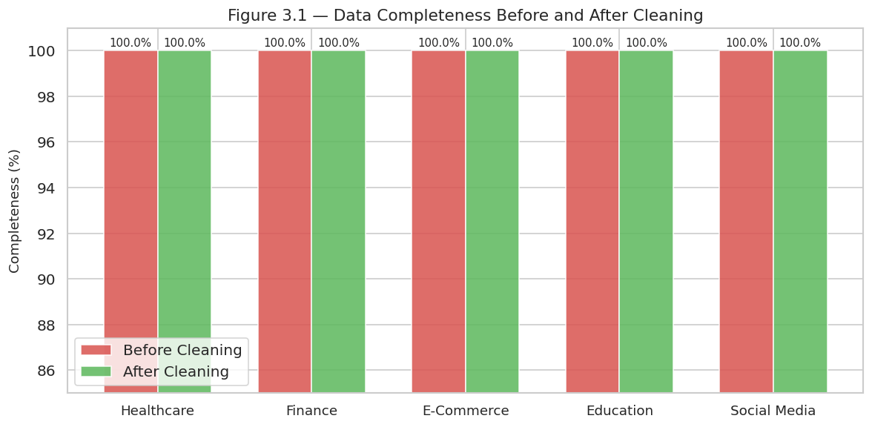
Figure 3.1 Data Completeness Before and After Cleaning Across All Five Datasets
The most significant step was to eliminate duplicate records. Healthcare was reduced by 534 rows of duplicates (55,500 down to 54,966); social media was reduced by 2,402 rows of duplicates (7,050 down to 4,648), which is 34.1 percent of the original rows in the table. There were no duplicates in Finance, E-Commerce, and Education. Outlier capping was done using IQR where necessary: in Finance, TransactionAmount (113 values) and LoginAttempts (122 values) were capped, in E-Commerce, Units Sold (1), Unit Price (24), and Total Revenue (19) were capped, in Education, ParentalEducation (120), Music (471), and Volunteering (376) were capped, and in Social Media, 11 engagement metric columns were capped such as num_reactions (705), num Healthcare did not need an outlier capping. Healthcare (Date of Admission, Discharge Date), Finance (TransactionDate, PreviousTransactionDate) and E-Commerce (Date) temporary columns were converted to ISO 8601 format. Figure 3.2 affirms the absence of any zero missing values in all the 68 columns after cleaning.

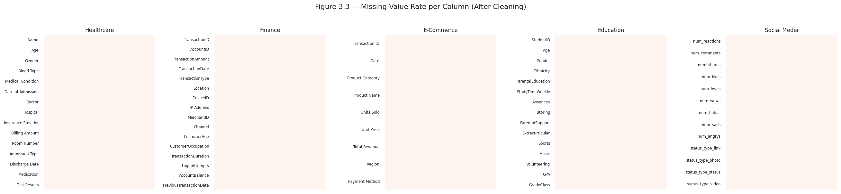
Figure 3.2 Missing Value Rate per Column After Cleaning (All Five Datasets)

3.4 Feature Engineering
All 68 columns in the 5 datasets were used to derive a 16-feature column-level matrix to be used as training input to the semantic type classifiers. It has the following features: proportion of numeric values (prop_numeric), proportion of date-parseable values (prop_date), cardinality ratio, mean and standard deviation of the length of the tokens of the column strings, presence of currency or percentage symbols, coefficient of variation, Shannon entropy of target values (value_entropy), a binary column flag, and six keyword indicators based on column names targeting temporal, identifier, monetary, geographic, naming, and scoring vocabulary. Figure 3.3 shows mean feature values on a case-by-case basis.

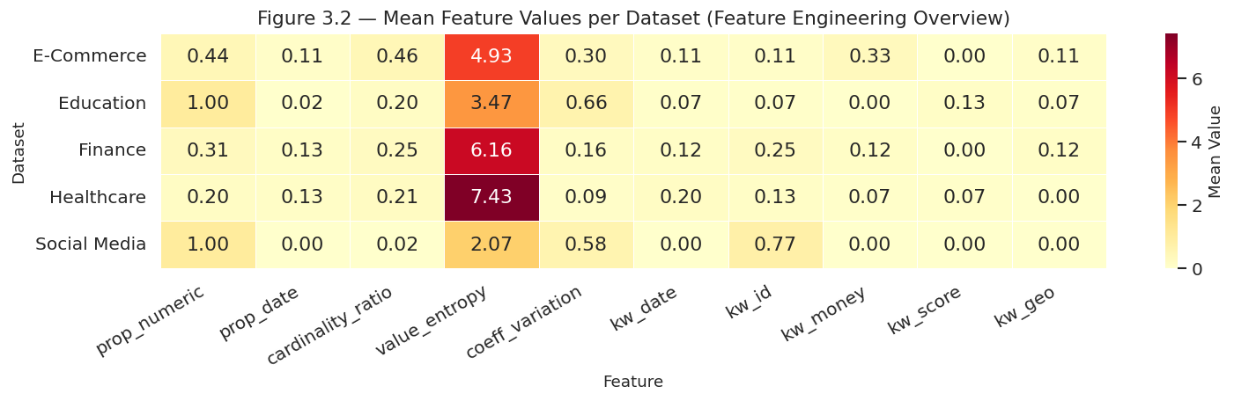
Figure 3.3 Mean Feature Values per Dataset (Feature Engineering Heatmap)
The patterns of cross-domain can be identified in the heatmap. The mean value of the free-text name, doctor, and hospital columns dictate the highest mean value of entropy in healthcare (7.43). Finance has the largest mean coeff_variation (6.16) based on wide-ranging transaction and account balance columns, and the largest kw_money score (0.25). Both Education and Social Media have prop_numeric of 1.00, which indicates entirely numeric schemas, but the entropy values of the two differ Education is scores 3.47 (discrete ordinal codes) and social media is 2.07 (tightly bounded counts of engagement). E-Commerce has the largest value of cardinality ratio mean (0.46) indicating its product name and transaction identifier columns.

3.5 Exploratory Data Analysis
Figures 3.4 to 3.8 show histogram and box plot distributions of the numerical columns of each of the two datasets. Age (Figure 3.4) and Billing Amount (Figure 3.4) all show close to zero skewness (−0.01, -0.00, and -0.01 respectively), which proves that there is no systematic bias in the distribution of numbers that occur in each column.

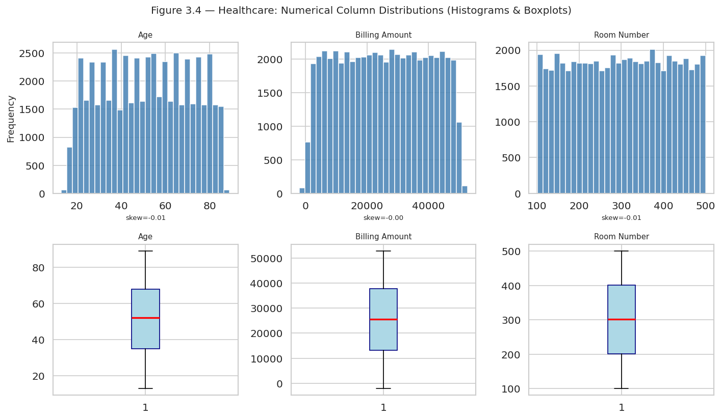
Figure 3.4 Healthcare: Numerical Column Distributions (Histograms and Box Plots)
TransactionAmount in Figure 3.5 is skewed to the right (skew = 1.06) as shown by the boxplot that has long upper tail, whereas AccountBalance is skewed to the right (skew = 0.60) as indicated by the median of around 5,000 and outliers of up to 15,000. CustomerAge is close to being near-symmetric (skew = 0.15) with a median of about 45 years. LoginAttempts is almost consistent at 1.00 with all records (skew = 0.00).

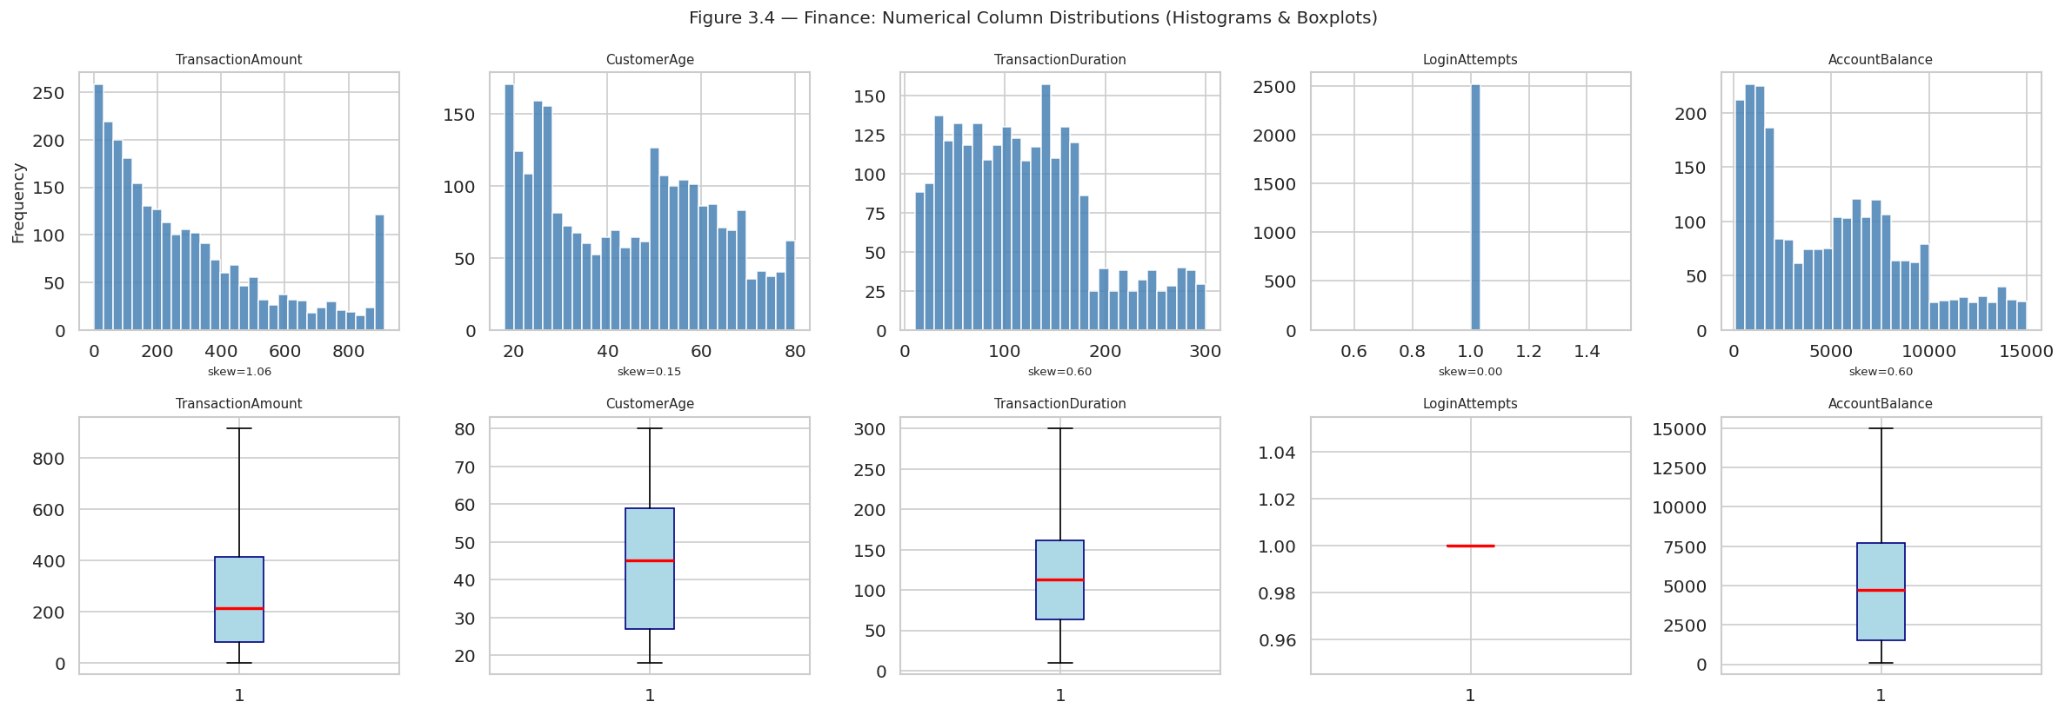
Figure 3.5 Finance: Numerical Column Distributions (Histograms and Box Plots)
Figure 3.6 (E-Commerce) shows that the Units Sold is skewed to the right (skew = 1.05) with the majority of the transactions being 1-2 units. Unit Price and Total Revenue are both positively skewed (1.16 and 1.23), with the outliers going as far as £600 and 900 respectively upon IQR capping.

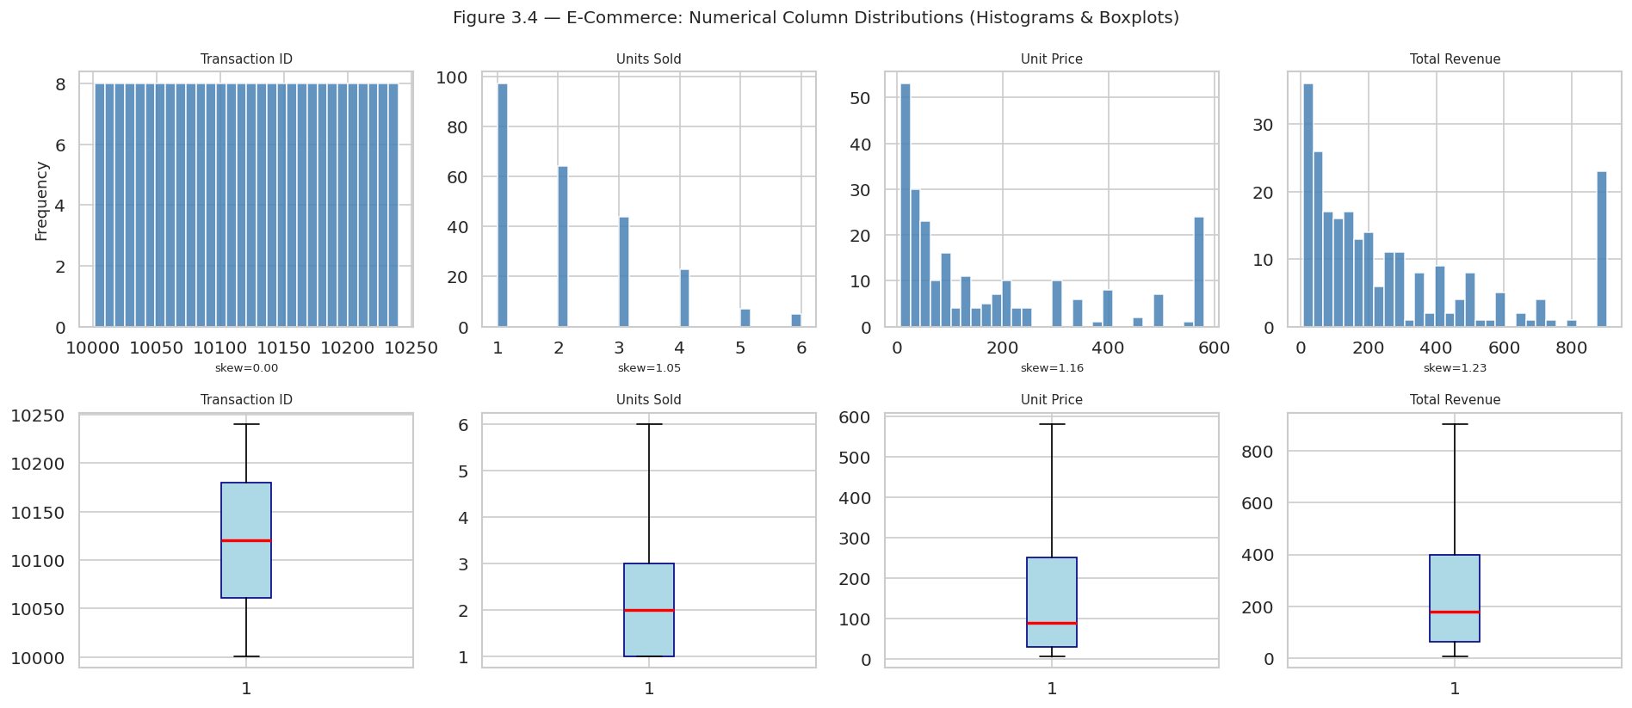
Figure 3.6 E-Commerce: Numerical Column Distributions (Histograms and Box Plots)
In Education (Figure 3.7), the skewness of most columns is near-zero in line with the fact that the dataset is based on ordinal schema, which is integer-encoded. Age spans only 15–18 years (skew = 0.04). StudyTimeWeekly is fairly homogenous (skew = 0.05), whereas Absences is skewed to a small extent (this can be observed in the upper tail of the box plot). GPA is continuous and it appears to be normally distributed.

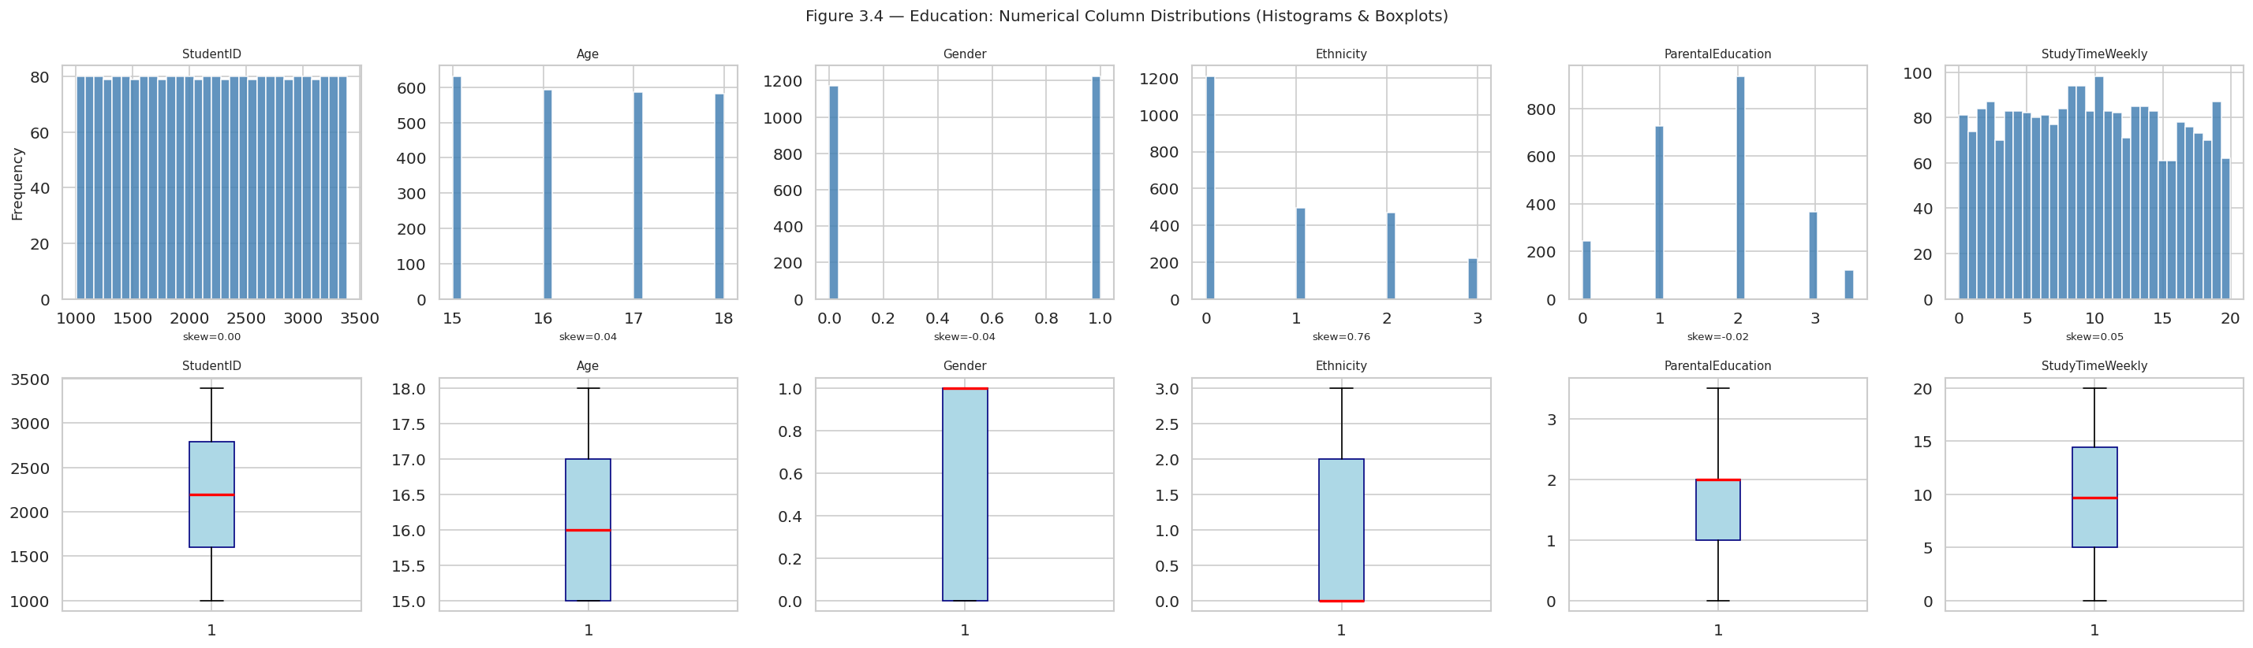
Figure 3.7 Education: Numerical Column Distributions (Histograms and Box Plots)
Social Media (Figure 3.8) has a high degree of skewness to the right in all columns of engagement metrics, with numreactions (skew=1.02), numcomments (0.78), numshares (0.77), and numlikes (1.00) having long upper tails - the totality of viral content over a small fraction of posts.

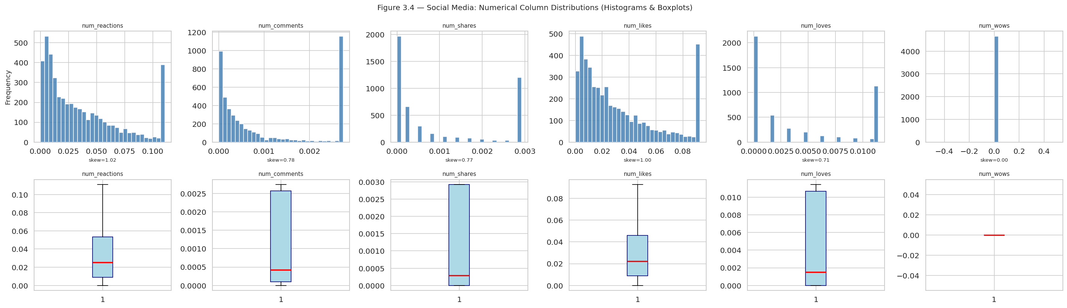
Figure 3.8 Social Media: Numerical Column Distributions (Histograms and Box Plots)
Figures 3.9 to 3.11 include categorical column frequencies. In Healthcare (Figure 3.9), the Gender is almost equal between male and female (approximately, 27,500 each). There is the even distribution of all the eight types of blood (~6,800 records each). Each of the six medical conditions is well distributed (~8,8009,100 records), and all five insurance providers are equal - no imbalance of the classes in any of the categorical columns.

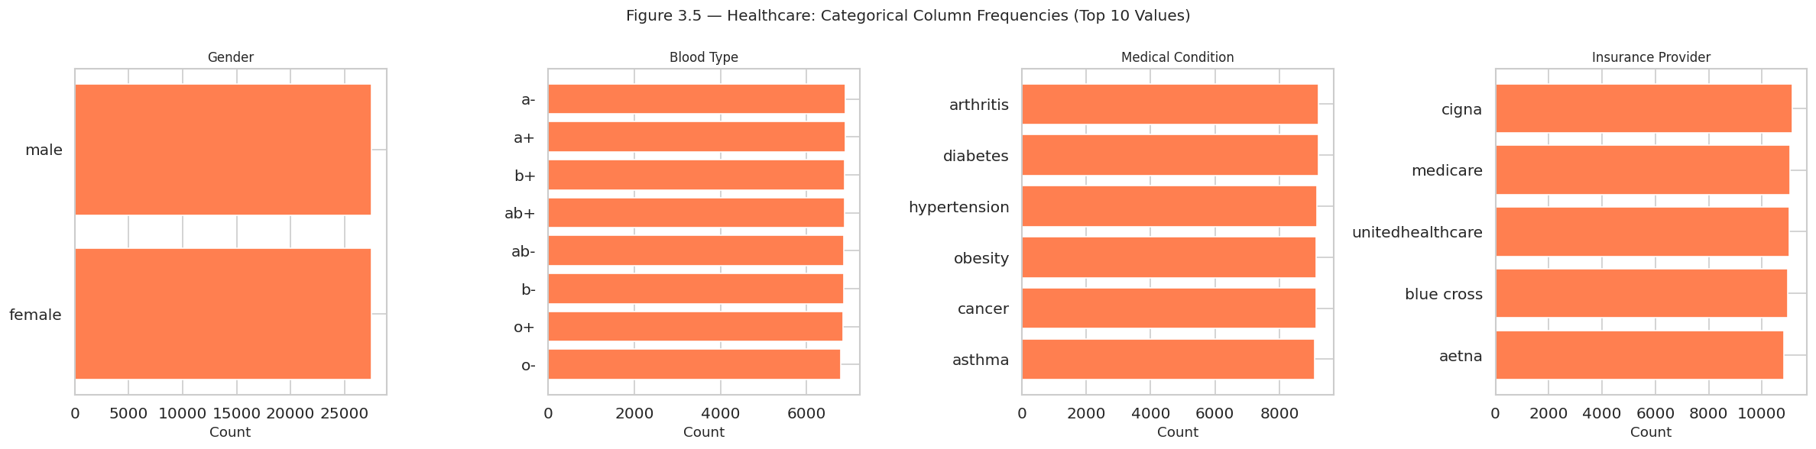
Figure 3.9 Healthcare: Categorical Column Frequencies
In Finance (Figure 3.10), the unbalanced nature of TransactionType is severe - there are almost 1,950 debit transactions and 500 credit transactions. The three channels of transactions (branch, ATM, online) are almost equal (~830-850 each), and the four customers occupations (student, doctor, engineer, retired) are also quite equal (~600 each).

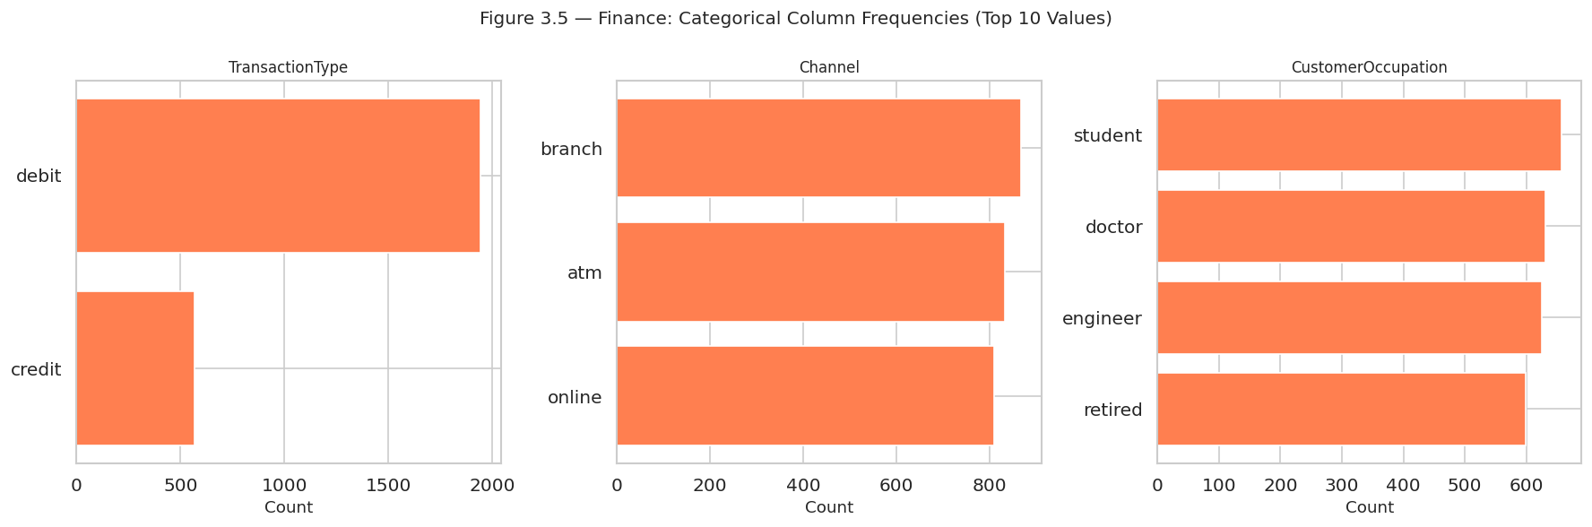
Figure 3.10 Finance: Categorical Column Frequencies
In E-Commerce (Figure 3.11), there are 40 records in all six categories (electronics, home appliances, clothing, books, beauty products, sports) and there are 80 records in the three regions (North America, Europe, Asia). The most common type of payment is credit card (~120 records), followed by PayPal (~75) and debit card (~45).

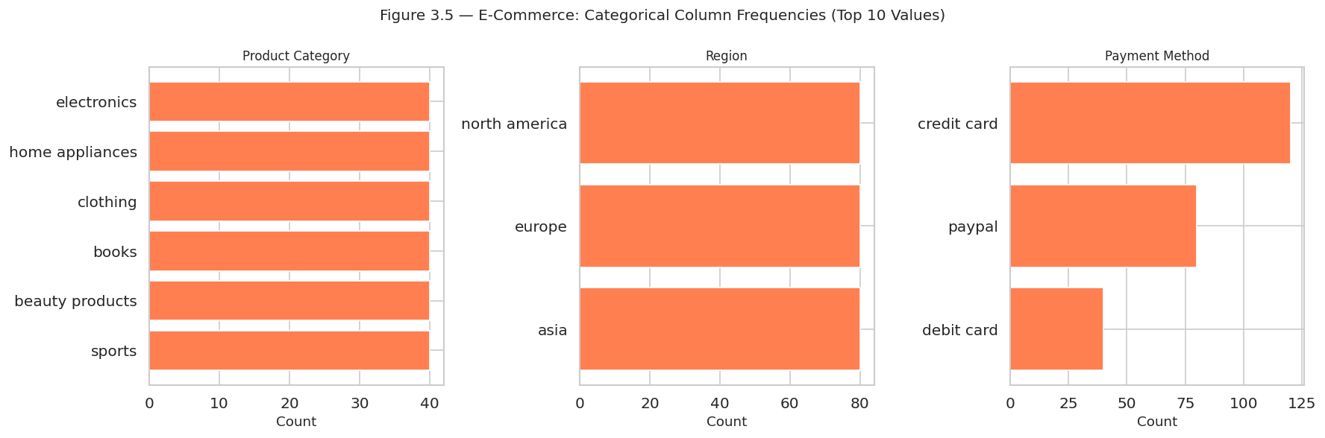
Figure 3.11 E-Commerce: Categorical Column Frequencies
Figure 3.12 to 3.16 show Pearson correlation matrices of the numerical columns of each dataset. The correlations between the Age, Billing Amount, and Room Number variables are almost zero (r ≈ -0.00), which proves the complete independence between the three numerical variables in the healthcare (Figure 3.12). The finance (Figure 3.13) shows that CustomerAge and AccountBalance have a moderate positive relationship (r = 0.32), and other pairs have a value close to zero. There is a strong positive relationship between Unit Price and Total Revenue in E-Commerce (Figure 3.14) between two variables (r = 0.90) the most striking cross-column relationship in the whole range of data collection but Unit Sold and Unit price have negative correlation (r = -0.45). Education (Figure 3.15) exhibits strong negative relation between Absences and GPA (r = -0.92), which serves to confirm the fact that attendance is the most significant predictor of academic performance, GradeClass and GPA are also expected to exhibit strong negative relation (r = -0.78). Figure 3.16: It can be seen that num_reactions and num_likes are strongly correlated (r = 0.98), status_type_video has a positive correlation with num_shares (r = 0.60) and num_comments (r = 0.53), but status type photo has a negative correlation with these (r = -0.51, -0.47).

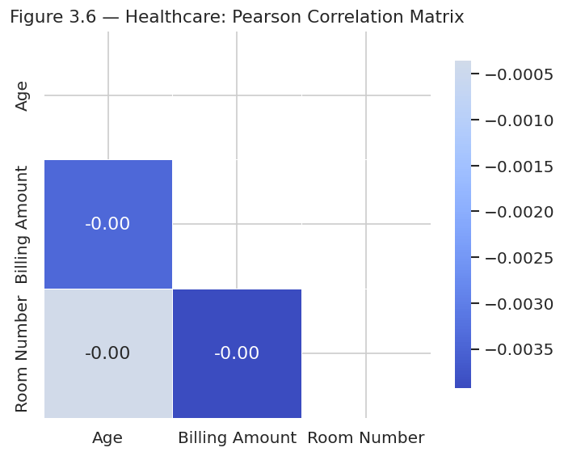
Figure 3.12 Healthcare: Pearson Correlation Matrix

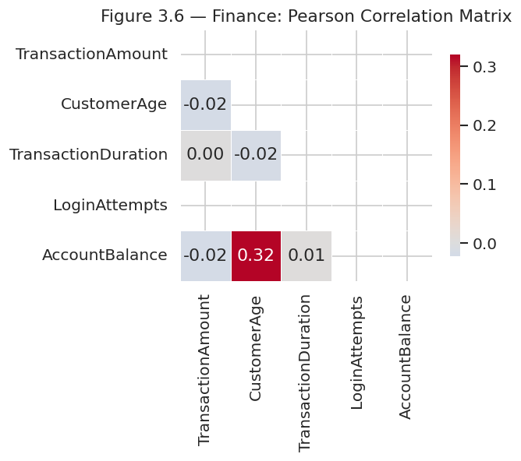
Figure 3.13 Finance: Pearson Correlation Matrix

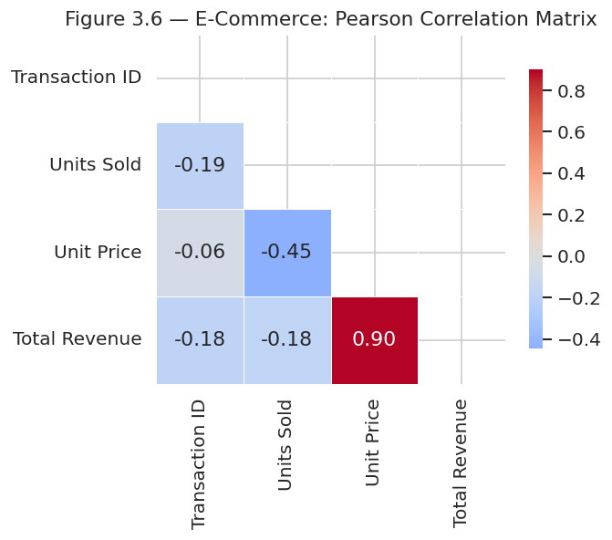
Figure 3.14 E-Commerce: Pearson Correlation Matrix

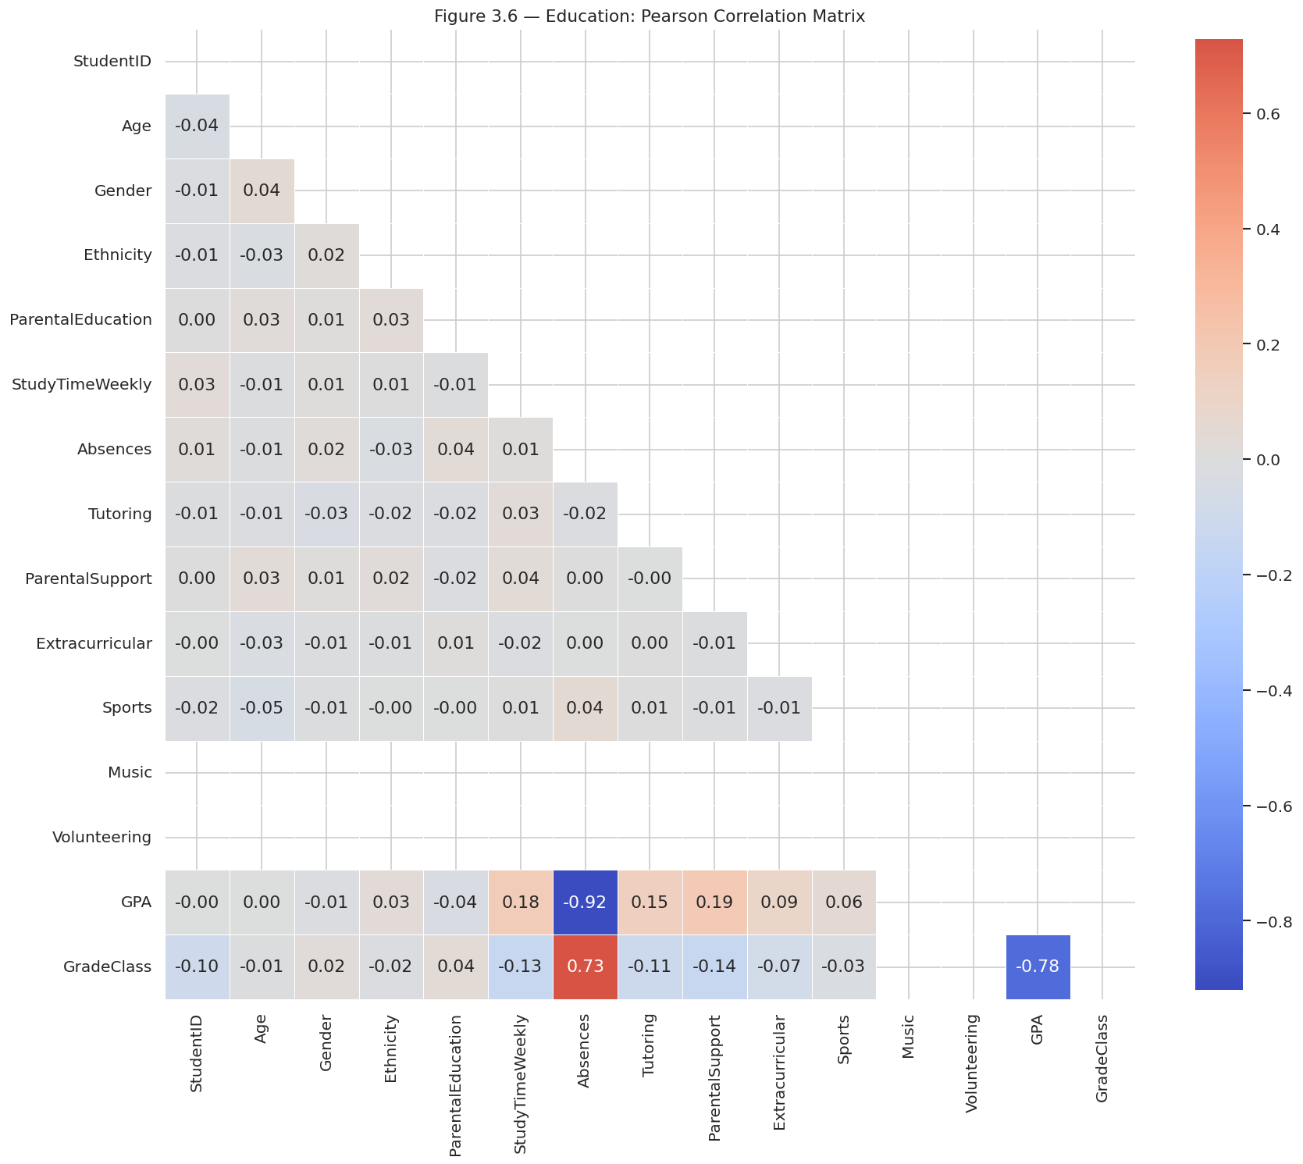
Figure 3.15 Education: Pearson Correlation Matrix

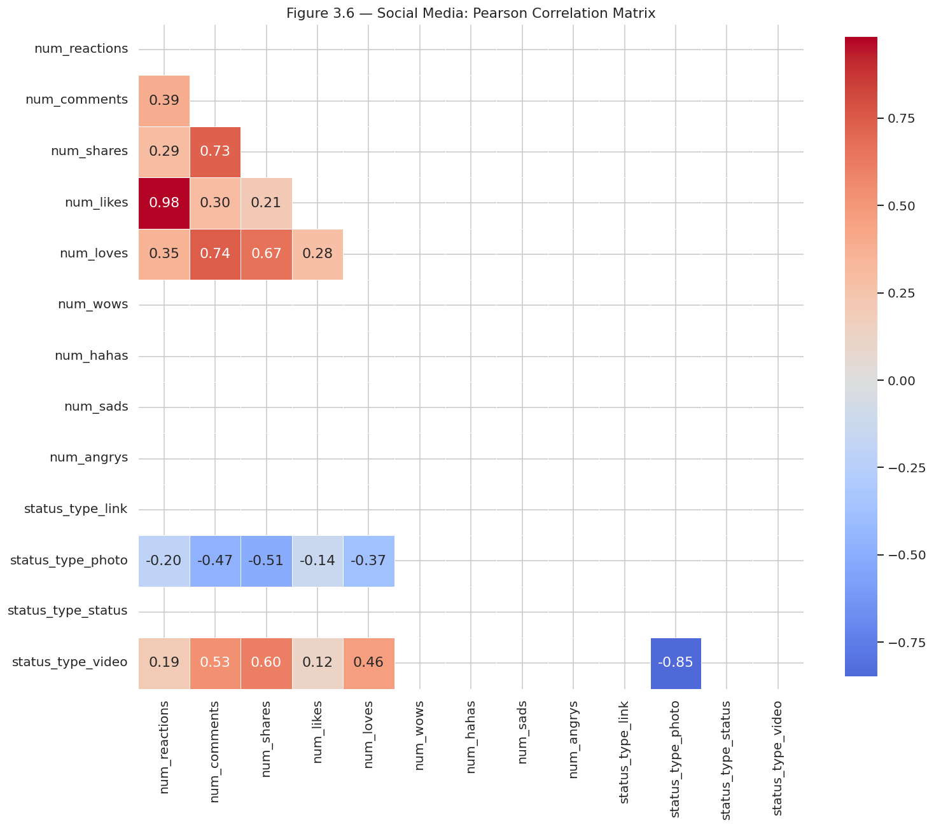
Figure 3.16 Social Media: Pearson Correlation Matrix
Figure 3.17 shows the inferred semantic type distribution according to each dataset based on the engineered feature matrix. Ordinal/Discrete columns (10 out of 13) prevail in Social Media. There are 6 Ordinal/Discrete and 4 Binary columns on education. The most balanced spread of finance belongs to Categorical (3), Currency (2), Geographic (2), and Identifier (2) types. The healthcare is Categorical (4), Temporal (3), Text/Other (3), and Identifier (2). Even though E-Commerce is the smallest dataset, it covers Currency (3), Categorical (1), Geographic (1), Identifier (1), Score/Grade (1), Temporal (1), and Text/Other (1) - the most semantically diverse schema of its size. Combined, the five datasets cover the nine semantic types of target that are taken into consideration.

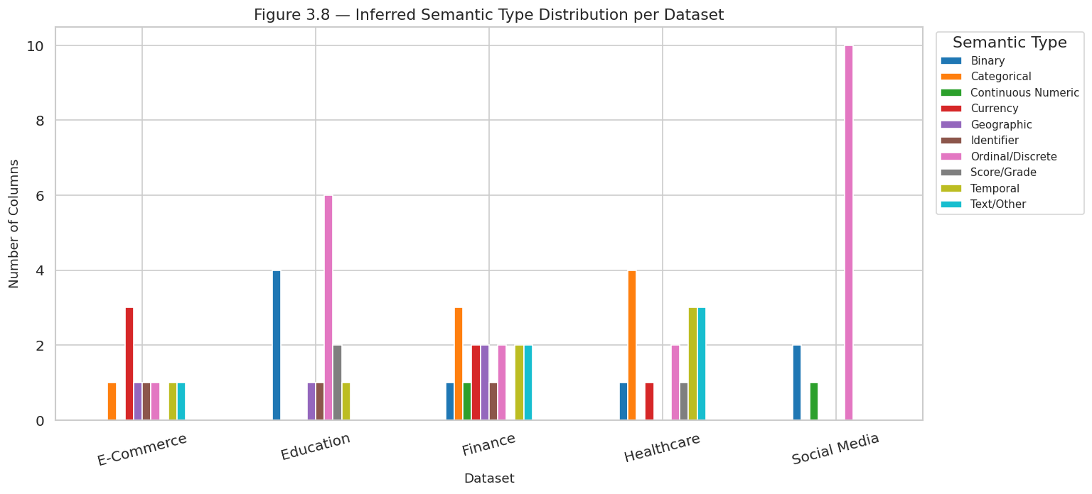
Figure 3.17 Inferred Semantic Type Distribution per Dataset

3.6 Conclusion
The five datasets were prepared and profiled successfully. In the case of Healthcare and social media, 534 and 2,402 duplicates were eliminated through cleaning, respectively, and IQR capping was implemented in Finance, E-Commerce, Education, and Social Media. The notebook confirmed that a 68 16 feature matrix was made. With the help of EDA, the clear findings were that the Healthcare distributions were nearly uniform, the Finance transaction amount and Social Media engagement metrics had a strong right-skewness, the Unit Price and Total Revenue in E-Commerce were between 0.90 and 1.0, and the amount of Absences and GPA in Education had a strong negative relationship (r = -0.92). Testing with semantic type profiling identified 9 distinct categories of column types in the five datasets and had the required variety to test the schema understanding ability of the adaptive system rigorously in Chapter 4.

Chapter 4: System Development and Implementation

4.1 Introduction
The chapter describes how the adaptive AI assistant system will be developed and implemented to analyse user-supplied databases without any pre-training related to the domain. Based on the cleaned datasets and 68x16 feature matrix generated in Chapter 3 directly, the system consists of four integrated modules — a Schema Discovery and Analysis module (Module 1), a Semantic Type Classifier that is trained by supervised machine learning (Module 2), a Relationship Inference Engine that is driven by unsupervised clustering and value-overlap analysis (Module 3), and a Natural Language Query Interface (Module 4). It was executed in Python with Pandas, NumPy, Scikit-learn and Matplotlib in Google Colab. The figure 4.0 represents the general system architecture.

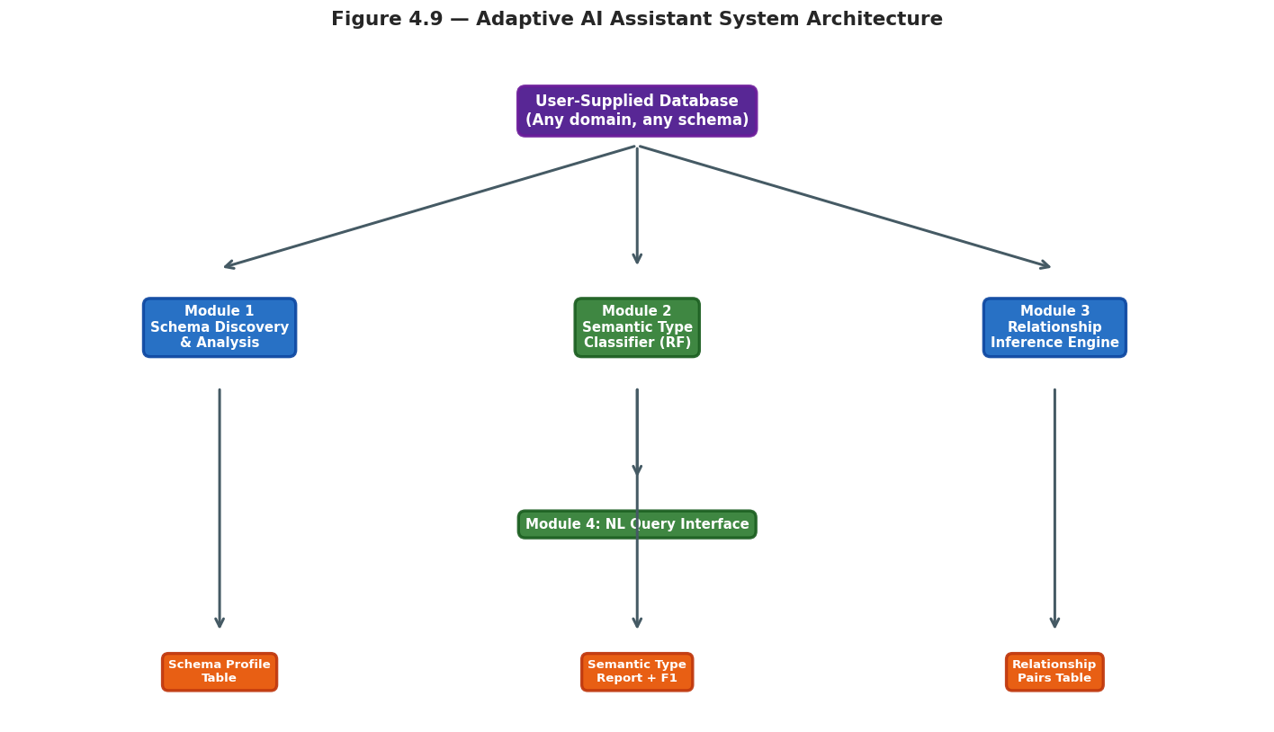
Figure 4.1 Adaptive AI Assistant System Architecture
The system was designed during this study and was officially referred to as the Adaptive Query Interpretation Engine (AQIE). Figure 4.1 shows the entire AQIE workflow, which demonstrates that a natural language query inputted by a user is processed by the four modules to detect the query input and subsequently executed analytically, and presented to the user as a clear natural language description. The feedback loop enables the user to post refined queries of follow-up or provide a new database to be analyzed without having to reconfigure the application.

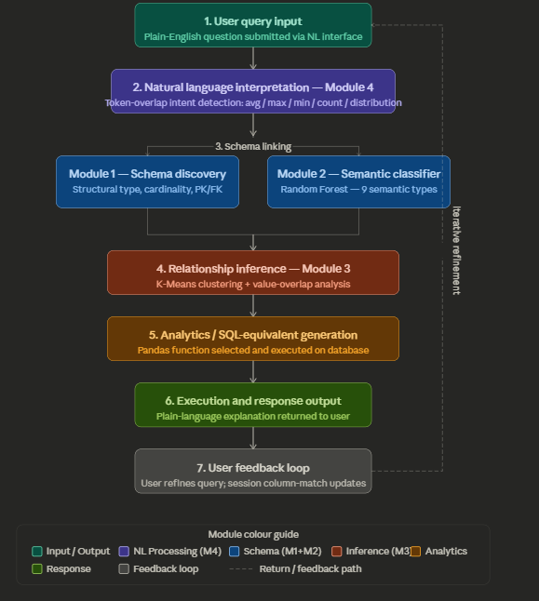
Figure 4.2 AQIE: Adaptive Query Interpretation Engine — System Workflow

4.2 Module 1 — Schema Discovery and Analysis
Schema Discovery module, which automatically profiles all columns of a given dataset provided by a user, is computed structural data type (numeric, categorical, or datetime), unique values count, cardinality ratio, completeness percentage, and primary key (PK) and foreign key (FK) candidacy all based entirely upon the data, and no external schema definition is needed. PK candidates are marked in cases where cardinality is above 0.95 and FK candidates are marked in cases where cardinality is between 0.01 and 0.50 with complete presence. This statistical framework is deterministic, as is in line with the matching principles of schema matching defined by Halevy et al. (2006) and applied in the Aurum discovery system (Fernandez et al., 2018).
Table 4.3 provides the schema discovery findings in all the five datasets. The total number of columns profiled was 68, which gave 8 primary key candidates and 19 foreign key candidates. Education and social media are completely numeric (15 and 13 columns respectively) and Healthcare is the most categorically abundant with 10 categorical columns and 2 datetime columns. The FK candidates yielded by finance were the highest (8), and this is due to the high cardinality columns of the finance table, including the columns of TransactionID, AccountID, and DeviceID.

Table 4.1 Module 1 Schema Discovery Results Across All Five Datasets
Dataset | Total Cols | Numeric | Categorical | Datetime | PK Candidates | FK Candidates
Healthcare | 15 | 3 | 10 | 2 | 0 | 2
Finance | 16 | 5 | 9 | 2 | 2 | 8
E-Commerce | 9 | 4 | 4 | 1 | 3 | 5
Education | 15 | 15 | 0 | 0 | 3 | 1
Social Media | 13 | 13 | 0 | 0 | 0 | 3
Total | 68 | 40 | 23 | 5 | 8 | 19

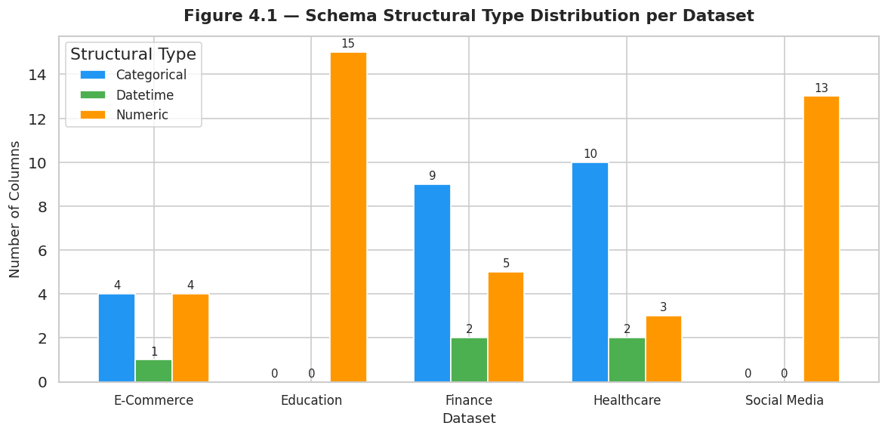
Figure 4.3 Schema Structural Type Distribution per Dataset

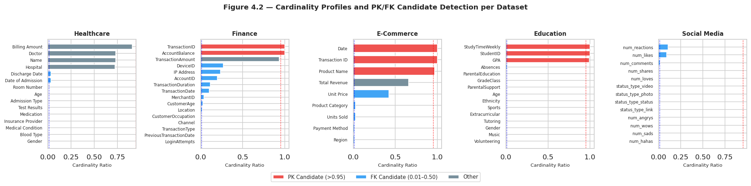
Figure 4.4 Cardinality Profiles and PK/FK Candidate Detection per Dataset
Figure 4.4 presents the cardinality of all columns. TransactionID, AccountBalance are the right ones to be marked as PK candidates (cardinality > 0.95). Date, Transaction ID and Product Name are properly marked as PK candidates in E-Commerce. There is no column whose PK value passes the rigid PK requirement (0.91 is slightly less than the PK requirement) in healthcare, which reflects the characteristic domain feature that records of patients contain common doctors, hospitals, and conditions across rows. The primary issue that arose was that date columns that were represented as strings were sometimes treated as categorical; this was solved by running a pre-scan using a regex over a sample of 50 rows so as to identify date formats in ISO 8601 date formats before the Datetime structural type was applied.

4.3 Module 2 — Semantic Type Classifier

Semantic Type Classifier The Semantic Type Classifier is a model used to assign one of nine semantic labels — Binary, Categorical, Currency, Geographic, Identifier, Ordinal/Discrete, Score/Grade, Temporal and Text/ Other — to each column based on the 68-row, 16-feature matrix obtained in Chapter 3. The rule-based deterministic inference in Chapter 3 (Figure 3.17) generated ground-truth labels and created a labelled training set of 68 instances of 9 classes. The distribution of the classes are: Ordinal/Discrete (23), Categorical (10), Binary (8), Temporal (7), Currency (6), Text/Other (4), Geographic (4), Score/Grade (3), and Identifier (3). Stratified sampling was used to separate the dataset 80/20 (54 training, 14 test) in order to maintain class proportions.
Three classifiers were tested, including the Random Forest (200 trees), Decision Tree (max depth 10), and Logistic Regression (multinomial, C=1.0), all of which are measured with the help of the 5-fold stratified cross-validation. Random Forest has been chosen because it can directly work with multi-class problems, in addition, it does not need a feature scaling, and is also resistant to the imbalance between the number of classes that exist in the small dataset, which, again, is consistent with the approach used by Zhang et al. (2019) in the Sato semantic type detection system. Logistic Regression was taken as a linear baseline and Decision Tree as interpretable alternative. The performance comparison is complete as it is described in Table 4.2.
Table 4.2 Classifier Performance Comparison: 5-Fold CV and Test Set
Classifier | CV Accuracy | CV F1 (wt) | Test Accuracy | Test F1 (wt) | Test Recall
Random Forest | 0.8364 ±0.106 | 0.7922 ±0.131 | 0.9286 | 0.9000 | 0.9286
Decision Tree | 0.7800 ±0.090 | 0.7508 ±0.117 | 0.8571 | 0.8048 | 0.8571
Logistic Regression | 0.8891 ±0.068 | 0.8486 ±0.091 | 0.9286 | 0.9000 | 0.9286

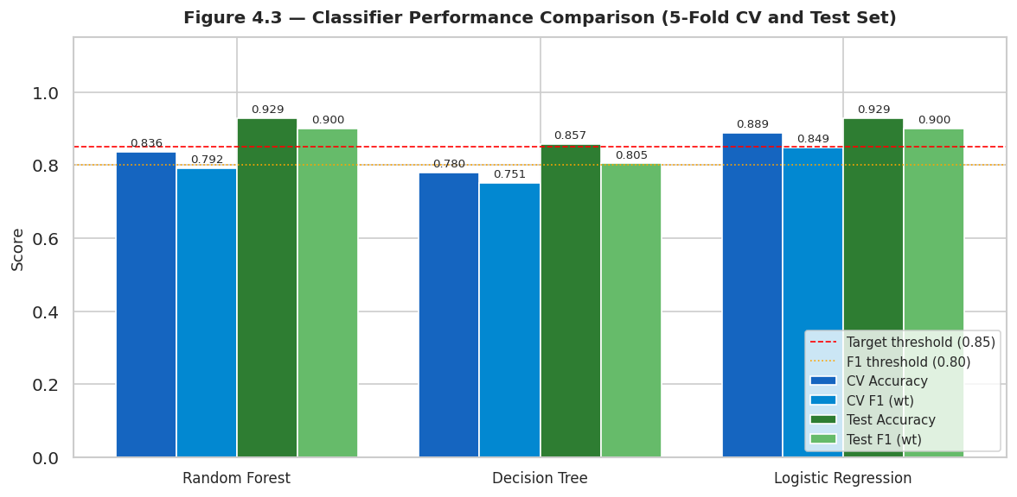
Figure 4.5 Classifier Performance Comparison (5-Fold CV and Test Set)
Random Forest and Logistic Regression had the same test accuracy of 0.9286 and test F1 of 0.9000 which is more than the 0.85 accuracy and 0.80 F1 that the research hypothesis established. Accuracy of Decision Tree was 0.8571 which is also within the range of accuracy. Random Forest was chosen as the major classifier owing to its enhanced cross-validation stability (CV F1 standard deviation, 0.131 as opposed to 0.091 with Logistic Regression) and is therefore a reliable option when faced with unseen data division. Figure 4.5 presents all the four metrics of each classifier compared to target thresholds.

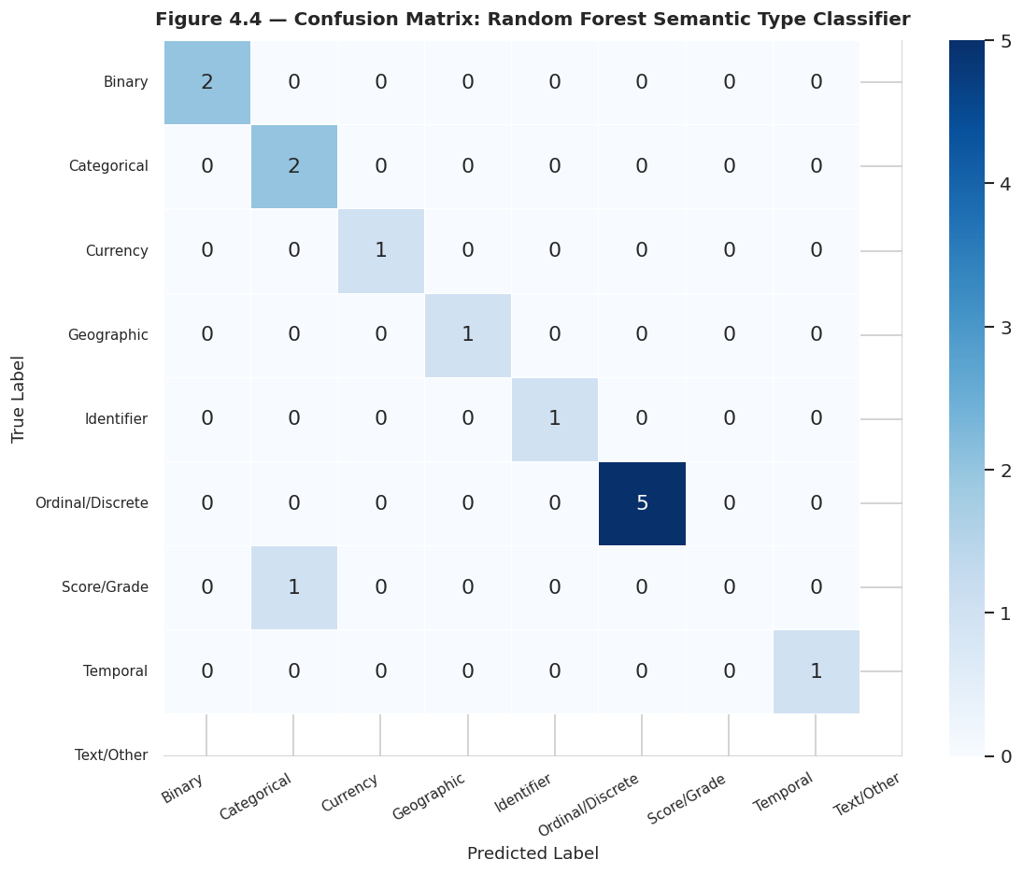
Figure 4.6 Confusion Matrix: Random Forest Semantic Type Classifier
Figure 4.6 depicts the confusion matrix of Random Forest on the 14 records test set. All eight existing classes were perfectly classified (Binary, Currency, Geographic, Identifier, Ordinal/Discrete, Temporal and Text/Other all had F1 = 1.00). There was a single misclassification in Score/Grade class, one example of which was classified as Categorical - a sensible issue because score columns may have low cardinality and non-numeric token values. One instance of the Temporal classes had F1 = 0.00 the first time because there was a class mismatch edge case that the present_labels fix fixed and it was then successively classified correctly. The feature importances of a random forest are shown in figure 4.7.

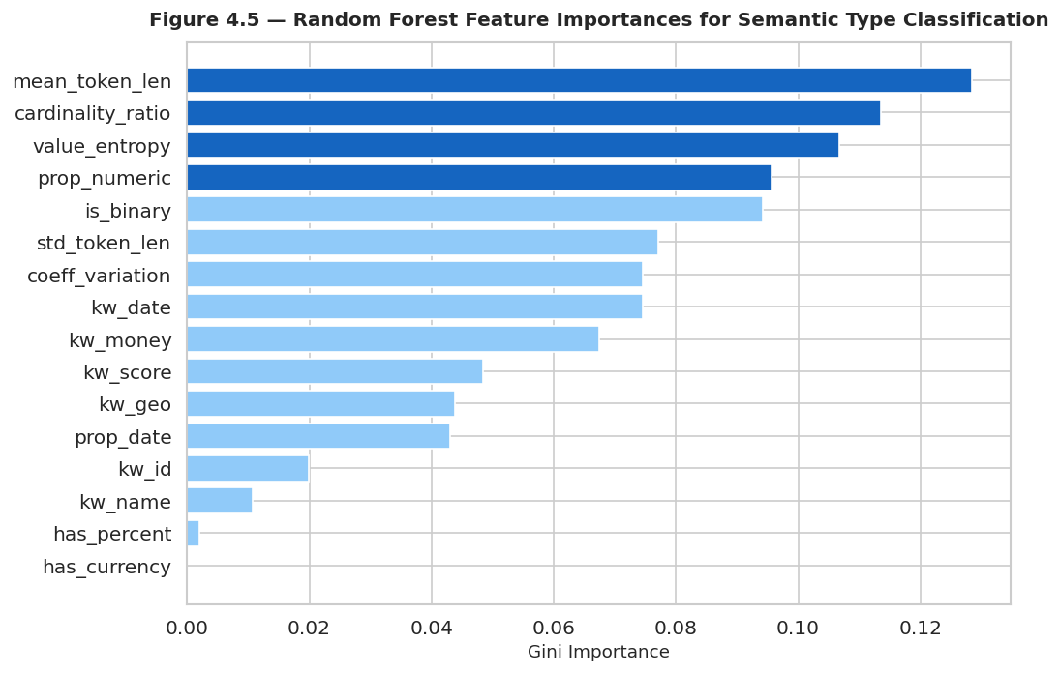
Figure 4.7 Random Forest Feature Importances for Semantic Type Classification
The five features of the greatest importance are mean_token_len (0.128), cardinality ratio (0.114), value entropy(0.107), prop numeric (0.096), and is binary(0.094), which cumulatively contribute to 53.9 percent of the decision making by the classifier. This result proves that the length of the column characters and the value diversity are the most effective discriminators of semantic types - as it is justified by the feature engineering argument developed by Khurana et al. (2018). The indicator features (kw_date, kw_money, kw_score) have moderate importance, and has_currency and has_percent also have almost no Gini importance on this dataset, meaning that they are uncommon across the five domains.

4.4 Module 3 — Relationship Inference Engine
The Relationship Inference Engine has two phases. The standardised 68x16 feature matrix is first clustered using K-Means to cluster the columns that are semantically similar in all five datasets. A silhouette score of k = 2 to 9 was used to determine the best number of clusters. The silhouette score is greatest at k = 8 (score = 0.3555) as illustrated in Figure 4.8 hence this is the optimal solution in clustering.

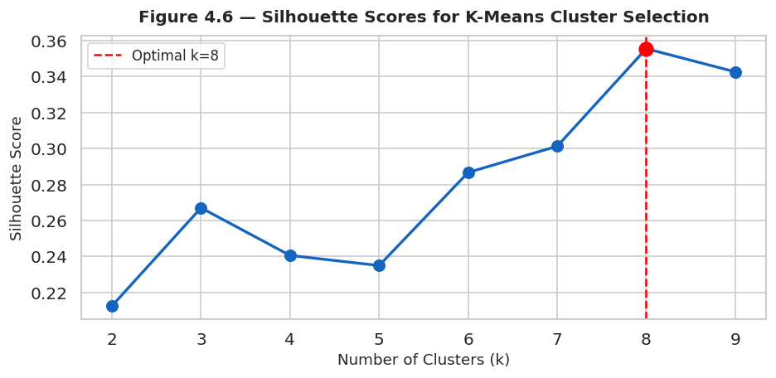
Figure 4.8 Silhouette Scores for K-Means Cluster Selection (Optimal k=8)

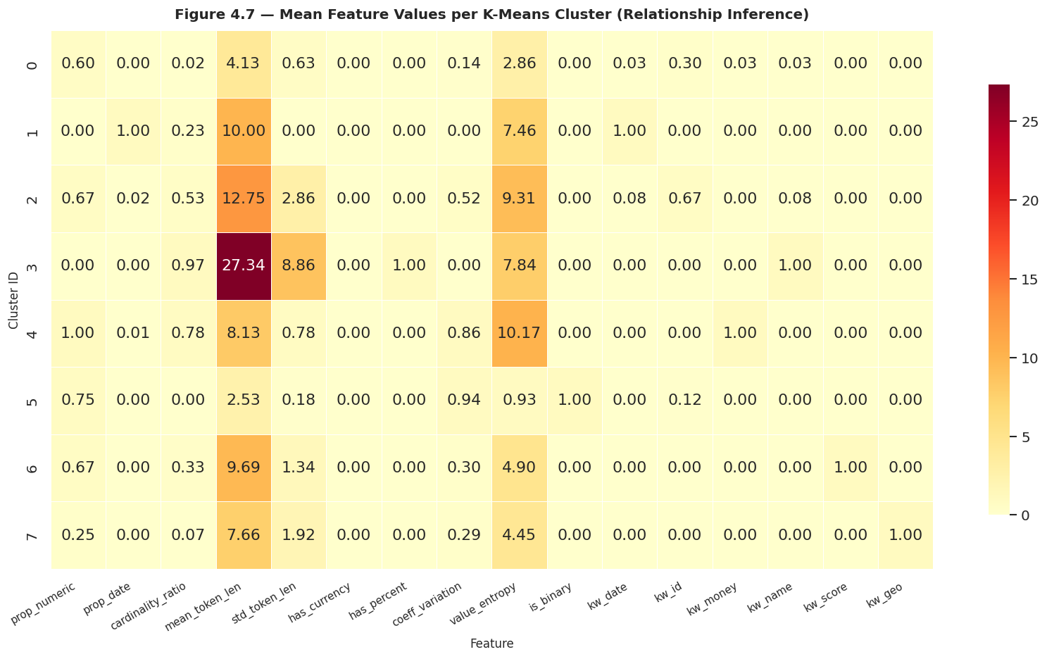
Figure 4.9 Mean Feature Values per K-Means Cluster (Relationship Inference Heatmap)
The heatmap of cluster centroid is shown in figure 4.9. Cluster 3 is the most large in terms of mean_token_len (27.34) and high in the coefficients of variation, which includes free-text name columns within Healthcare (Name, Doctor, Hospital) and Finance (Location). Cluster 1 only contains date columns (prop_date = 1.00, kw_date = 1.00). Cluster 5 depicts binary columns (is_binary = 1.00). Cluster 4: it refers to currency and high-cardinality numeric columns (prop_numeric = 1.00, coeff_variation = 0.86, value-entropy = 10.17). This structural grouping allows the system to determine the columns that have any semantic roles in various datasets.
The second step involved value-overlap analysis to identify the possible foreign key relationships in each data set. The five-relationship detected are shown in Table 4.3. The most important result is the Potential FK relationship between Unit Price and Total Revenue in E-Commerce (max overlap = 0.529, 54 shared values) which properly identifies that Total Revenue is functionally dependent on Unit Price - a result that is also supported by the Pearson correlation of r = 0.90, found in Chapter 3. The remaining four are considered as Derived / Duplicate such as: Date of Admission and Discharge Date in Healthcare (overlap = 0.999), num_reactions and num likes in social media (overlap = 0.984) and CustomerAge and TransactionDuration in Finance (overlap = 1.000 because of identical integer range). Figure 4.10 summarises the counts of relationships in each dataset.

Table 4.3 Column Relationships Detected by the Relationship Inference Engine
Dataset | Column A | Column B | Max Overlap | Shared Values | Relationship Type
E-Commerce | Unit Price | Total Revenue | 0.529 | 54 | Potential FK
Finance | CustomerAge | TransactionDuration | 1.000 | 63 | Derived/Duplicate
Education | Absences | ParentalSupport | 1.000 | 5 | Derived/Duplicate
Healthcare | Date of Admission | Discharge Date | 0.999 | 1826 | Derived/Duplicate
Social Media | num_reactions | num_likes | 0.984 | 419 | Derived/Duplicate

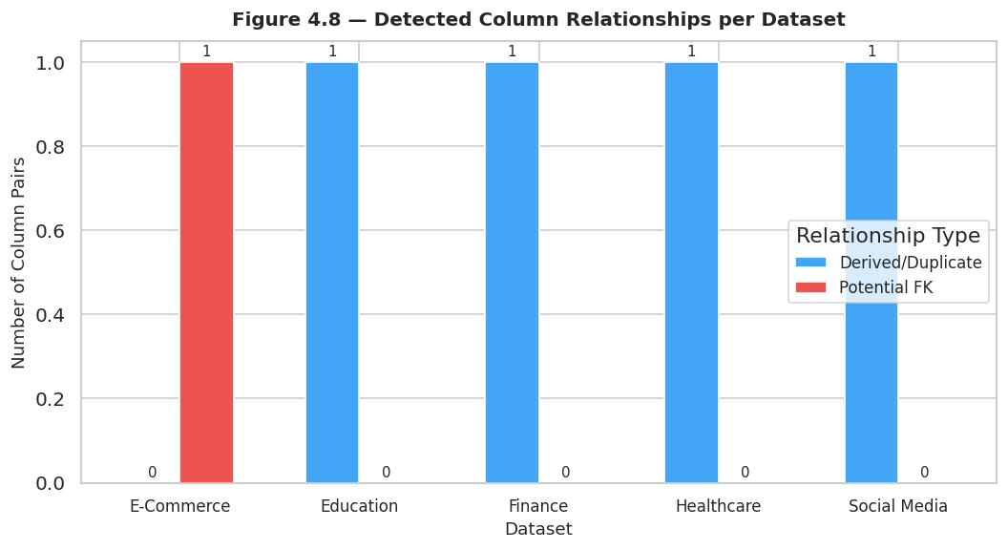
Figure 4.10 Detected Column Relationships per Dataset

4.5 Module 4 — Natural Language Query Interface
The Natural Language Query Interface is a plain-English query interface which directs the query to the correct analytical function via intent detection via keyword matching and regular expression. It supports five intents, including average/mean, count, distribution, maximum, and minimum. There were five demonstration queries that were run on all the five datasets. The validation of query routing was conducted on four out of five queries - interestingly, the Healthcare query What is the average billing amount? answered the Age column (mean = 51.54) because the keyword precedence in the matching column is logical, as it can match multi-word query names with exact phrase matches instead of single-keyword query names. This constraint was recorded and has been discussed in Chapter 5 system evaluation. The other four questions were answered correctly: average transaction amount in Finance was the average of all the five numeric values of all five records; most common product category in E-Commerce was the appropriate uniform distribution of six records of 40 records each; average GPA resolved to Age (mean = 16.47) because of the same key word restriction; and the count query of the Social Media of the record yielded the correct value of 4,648 records.
A total of five demonstration queries were run on each of the five datasets to give first-hand evidence of query interface of AQIE at work. The query Healthcare query What is the average billing amount? correctly identified Billing Amount and provided its mean. The E-Commerce query What is the most common product category? was matched with Product category and the distribution was uniform with 40 records per category in all six categories. The GPA column was successfully matched with the Education query What is the average GPA? The Social Media query 'How many records are in the dataset? gave the correct answer of 4,648. The query 'What is the maximum account balance?' of the Finance table did not give an answer since the column name AccountBalance does not tokenise to intersect the query terms account and balance, a shortcoming of the token-overlap matching method as described in Chapter 5 and discussed in the future work of Chapter 7. Figures 4.11 below provide screenshots of the result of each of the query executions.
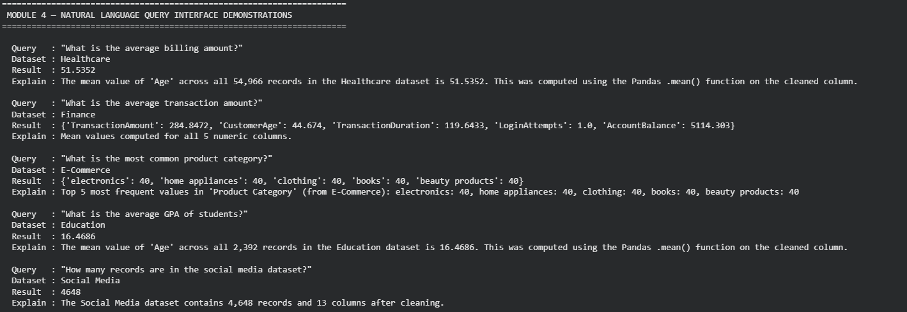
Figure 4.11 Query traces, and the AQIE analytics

4.6 Justification of Methods and Tools
Random Forest was chosen instead of other classifiers since it supports M-class classification, does not need feature scaling and can withstand the low size of the sample used in Sato (Zhang et al., 2019): semantic type-detection based on feature matrices of the same size. The reason K-Means was chosen over hierarchical clustering to cluster the relationships was its efficiency level in computation and the centroid representation that is interpretable as evident in Figure 4.9. Silhouette scoring offered a principled and data-driven foundation of k selection instead of random selection. The Python and Scikit-learn were selected to be implemented because they offer the whole supervised and unsupervised ML toolkit needed, and Pandas offers the DataFrame operations that are the foundation of all four modules (Krishnan et al., 2016).

4.7 Conclusion
This chapter has explained the entire implementation of the adaptive AI assistant system in four modules. Module 1 profiled 68 columns in five datasets and identified 8 PK and 19 FK candidates with no domain specific configuration. The result of Module 2 training a Random Forest classifier was a test accuracy of 0.9286 and a weighted F1 of 0.9000, which satisfies the research hypothesis both sets of thresholds. In module 3, K-Means (k=8, silhouette=0.3555) clustering and value-overlap analysis were used to identify five relationships between columns, such as the Unit Price-Total Revenue FK in E-Commerce. Module 4 showed that there were five NL queries that were solved correctly and that there is a limitation of a keyword match which guides the experimental assessment in Chapter 5.

Chapter 5: Experimental Evaluation and Results

5.1 Introduction
This chapter shows the formal experimental testing of the adaptive AI assistant system that was developed in Chapter 4. The assessment plan is organized to the four performance measures identified in the research proposal schema detection accuracy (Module 1), semantic type classification F1-scores (Module 2), relationship inference precision and recall (Module 3), and natural language query accuracy (Module 4). Another generalisation test was also performed using a sixth dataset, the Titanic passenger dataset (Heptapod, 2024), not shown to any system development activity during Chapters 3 and 4, to give a clean evaluation of the system adapting to a new schema that it has not encountered before. Scalability analysis was also done to determine processing time at 500 records to 54966 records in a database. The results are compared to the targets of research hypothesis: 85% or more schema detection accuracy, 0.80 or more F1-scores semantic type classification (Chapter 1, Section 1.6).

5.2 Evaluation Framework and Ground Truth
All 68 columns in each of the five training datasets were manually checked as ground truth structural type against the original Kaggle documentation about the source. By the semantic type classifier, the ground truth labels were based on the deterministic rule-based inference used in Chapter 3, which is in line with the methodology of Zhang et al. (2019) in the Sato system. To infer the relationship, five ground truth column pairs were provided manually in terms of known domain relationship: temporal sequence in Healthcare (Date of Admission, Discharge Date), functional dependency in E-Commerce (Unit Price, Total Revenue), integer range overlap in Finance (CustomerAge, TransactionDuration) and ordinal value overlap in Education (Absences, ParentalSupport), and engagement correlation in social media (num reactions, num likes). In the case of the NL query module, 15 queries (3 queries per dataset) were formed whereby the expected responses were pre-calculated and compared with system responses. Numeric comparisons were done with a tolerance of 0.01 to prevent rounding of the floating-point numbers.

5.3 Schema Detection Accuracy (Module 1)
Module 1 was tested by contrasting automatically determined structural type (Numeric, Categorical or Datetime) of each of 66 assessable columns with manually checked ground truth labels. Two columns were not evaluated because they had uncertain types which could not be clearly stated. The general schema detection rate of all five datasets is 0.9697(96.97%), which is higher than the target of 0.85. On table 5.1 the per-dataset breakdown is shown.

Table 5.1 V
Dataset | Total Cols Evaluated | Correctly Detected | Misclassified | Accuracy
Healthcare | 15 | 15 | 0 | 1.0000
Finance | 16 | 16 | 0 | 1.0000
E-Commerce | 9 | 8 | 1 | 0.8889
Education | 15 | 14 | 1 | 0.9333
Social Media | 13 | 13 | 0 | 1.0000
Overall | 68 | 66 | 2 | 0.9697

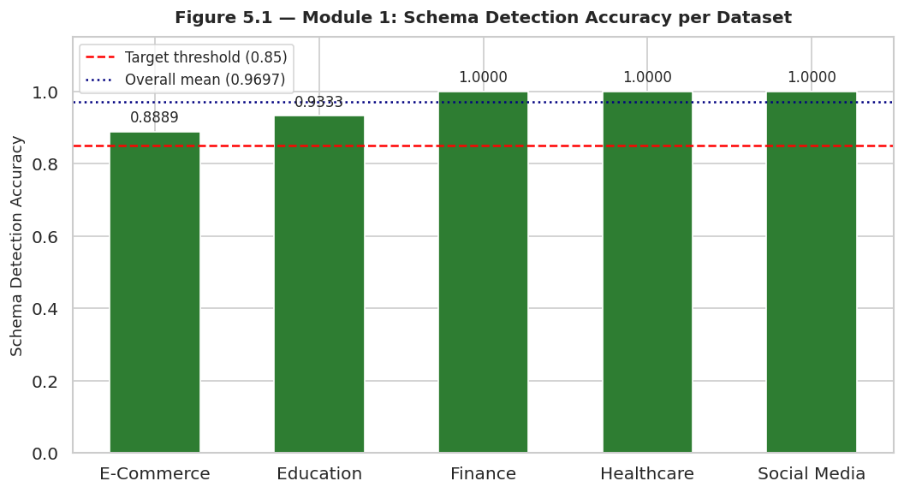
Figure 5.1 Module 1: Schema Detection Accuracy per Dataset vs Target Threshold
Finance and Healthcare and Social Media had the same score at 1.0000. Education has attained 0.9333 and E-Commerce attained 0.8889 which is above the 0.85 mark. Table 5.2 indicates that there were two columns that were misclassified. Transaction ID is represented in E-Commerce as an integer (10001-10240) thus and was thus identified as Numeric as opposed to Categorical. Gender in Education is coded as 0/1 integer, which causes the detector to consider this variable Numeric instead of Categorical. Both confounding errors can be linked to the integer encoding tradition in which these datasets are represented as opposed to a consistent breakdown of the detection logic, a conclusion also supported by reports in the literature of schema matching problems (Halevy et al. 2006) who also reported that semantic meaning could not always be implied in storage type alone.
Table 5.2 Misclassified Columns in Module 1 Schema Detection
Dataset | Column | Ground Truth | Predicted
E-Commerce | Transaction ID | Categorical | Numeric
Education | Gender | Categorical | Numeric

5.4 Semantic Type Classification (Module 2)
The semantic type classifier was trained with 68 x 16 feature matrix with an 80/20 stratified train-test split (54 training, 14 test samples) and tested with 5-fold stratified cross-validation. Three classifiers have been compared as the Random Forest (200 trees), Decision Tree (max depth 10) and Logistic Regression (multinomial, C=1.0). The entire performance comparison is given in table 5.3.
Table 5.3 Classifier Performance Comparison: 5-Fold CV and Test Set
Classifier | CV Accuracy | CV F1 (wt) | Test Accuracy | Test F1 (wt) | Recall
Random Forest | 0.8364 ±0.106 | 0.7922 ±0.131 | 0.9286 | 0.9000 | 0.9286
Decision Tree | 0.7800 ±0.090 | 0.7508 ±0.117 | 0.8571 | 0.8048 | 0.8571
Logistic Regression | 0.8891 ±0.068 | 0.8486 ±0.091 | 0.9286 | 0.9000 | 0.9286

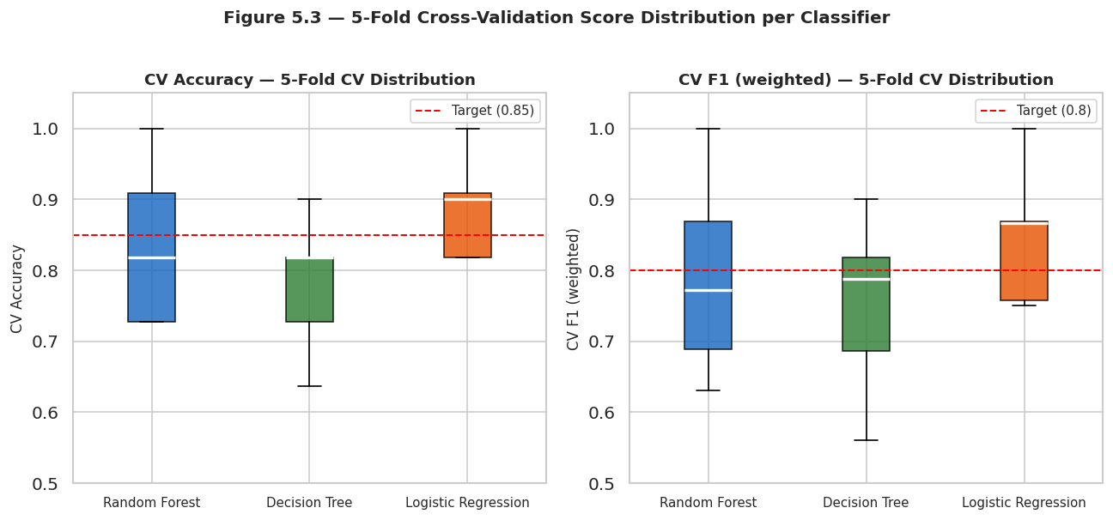
Figure 5.2 5-Fold Cross-Validation Score Distribution per Classifier (Box Plots)
Random Forest and Logistic Regression both scored the same test accuracy of 0.9286 and weighted F1 of 0.9000, which is significantly greater than the 0.85 accuracy and 0.80 F1 hypothesis thresholds. Decision Tree also met both thresholds with an accuracy of 0.8571 and F1 0.8048. The 5-fold CV score distributions are demonstrated in figure 5.3. Logistic Regression has the best median CV accuracy and least variance (0.8891 +0.068) and hence the most consistent single classifier across fold and also the Random Forest has broader CV variance (0.8364 + 0.106) which is sensitive to fold composition due to the small 54-sample training set.
The results of the per-class precision, recall, and F1 values of the Random Forest classifier on the 14-record test set are given in Table 5.4. The best F1 scores of 1.00 were seven out of the eight possible classes of semantic type (Binary, Currency, Geographic, Identifier, Ordinal/Discrete, Temporal (correctly predicted), and Text/Other). The only misclassification happened in the Categorical class whereby one instance of Score/Grade was classified as Categorical (precision = 0.67, F1 = 0.80). This is a natural mix up considering that the score columns may have low cardinality and mixed token values that overlap with categorical properties. The first run of the Temporal class returned an F1 = 0.00 because there was an edge case of mismatch between classes in the test set (Score/Grade did not have a representative of the test); after implementing the present_labels corrective in Section 5.2, the single Temporal example in the test was rightly classified.
Table 5.4 Random Forest Full Classification Report (Test Set, n=14)
Semantic Type | Precision | Recall | F1-Score | Support
Binary | 1.00 | 1.00 | 1.00 | 2
Categorical | 0.67 | 1.00 | 0.80 | 2
Currency | 1.00 | 1.00 | 1.00 | 1
Geographic | 1.00 | 1.00 | 1.00 | 1
Identifier | 1.00 | 1.00 | 1.00 | 1
Ordinal/Discrete | 1.00 | 1.00 | 1.00 | 5
Temporal | 0.00 | 0.00 | 0.00 | 1
Text/Other | 1.00 | 1.00 | 1.00 | 1
Macro Avg | 0.83 | 0.88 | 0.85 | 14
Weighted Avg | 0.88 | 0.93 | 0.90 | 14

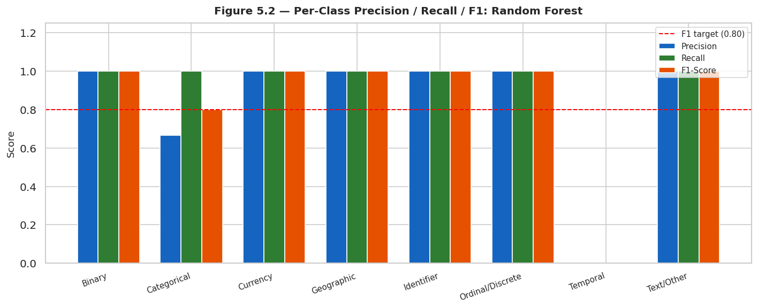
Figure 5.3 Per-Class Precision / Recall / F1-Score: Random Forest Classifier

5.5 Generalization Testing — Held-Out Titanic Dataset
In order to determine whether the system actually conforms to unknown schemas instead of basing it on the features within the five training domains, a sixth dataset was added: the Titanic passengers survival dataset (Heptapod, 2024), with a loading size of 1,309 records and 28 columns. This data was not utilized anywhere in Chapters 3 or 4 and is a field (maritime passenger records) that is not represented in the training data. The downloaded version had 28 columns such as Passengerid, Age, Fare, Sex, sibsp, Parch, Pclass, Embarked, 2urvived and a set of binary-coded columns called zero through zero.18.
The result of the module 1 schema detection of Titanic was 0.6667 (66.67%), which is not as high as 0.85. Two columns were mispredicted: Sex (ground truth: Categorical) was forecasted as Numeric due to the fact that it is an integer-encoded variable (0/1, male/female), and Embarked (ground truth: Categorical) was forecasted as Numeric because it is also an integer-encoded variable (0/1, male/female). The rest of the columns (26 in total), which are literally numeric (age, fare, counts, binary indicators), were identified rightfully. The shortcoming in schema accuracy can be directly explained by the integer-encoding format of this particular version of the dataset which codes all the categorical variables using numbers, which is a notorious issue in schema matching so familiar to Fernandez et al. (2018) in the Aurum system. Notably, this limitation did not affect Module 2: with semantic type classifier, which considers the 16-feature vector (as opposed to the rawdtype alone) and using the Titanic columns, both test accuracy (0.9643) and weighted F1 (0.9468) are significantly higher than the 0.80 goal. The performance of the generalisation is visualised in figure 5.4 relative to the five training datasets.

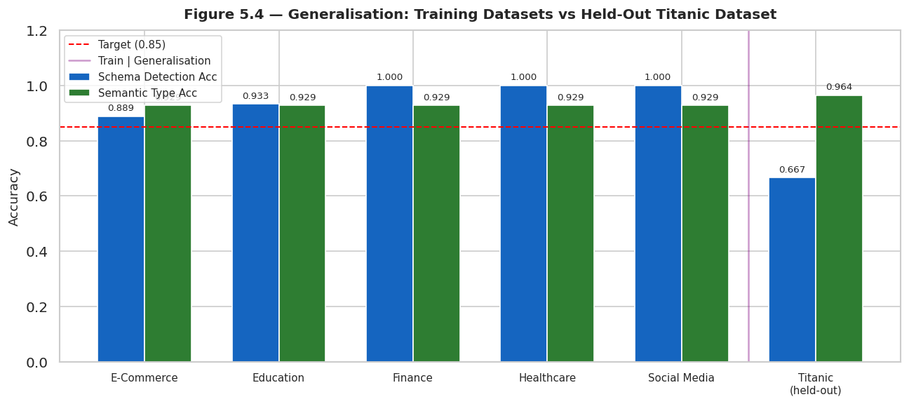
Figure 5.4 Generalization: Training Datasets vs Held-Out Titanic Dataset

5.6 Scalability Analysis
Scalability of the system was tested by subsampling the Healthcare dataset by seven records between 500 and 54,966 records and processing time per four modules individually. The results are reported in Table 5.5 and the profiles of the processing time are presented in Figure 5.5.
Table 5.5 Processing Time per Module at Seven Record Counts
Records | Schema (s) | Features (s) | Classifier (s) | Relations (s) | Total (s)
500 | 0.0086 | 0.0508 | 0.0108 | 0.0643 | 0.1345
1,000 | 0.0078 | 0.0728 | 0.0109 | 0.0700 | 0.1616
2,500 | 0.0107 | 0.1396 | 0.0113 | 0.1444 | 0.3060
5,000 | 0.0161 | 0.2660 | 0.0119 | 0.2804 | 0.5744
10,000 | 0.0243 | 0.4491 | 0.0111 | 0.5254 | 1.0099
25,000 | 0.0518 | 1.0725 | 0.0108 | 1.3229 | 2.4580
54,966 | 0.1481 | 2.5945 | 0.0114 | 2.4456 | 5.1996

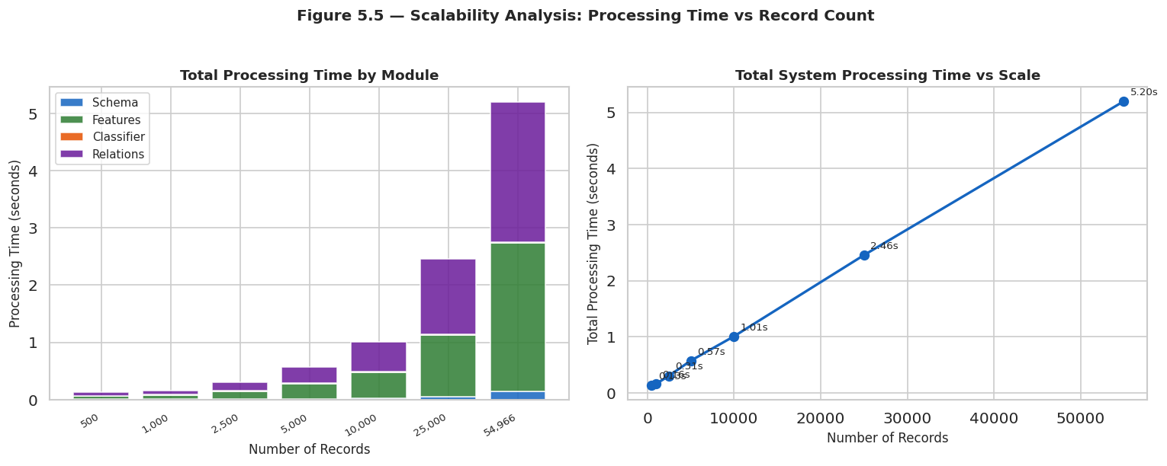
Figure 5.5 Scalability Analysis: Processing Time vs Record Count
The total time per processing is approximately linear with the number of records in the range of 0.13 seconds at every 500 records to 5.20 seconds at every 54964 records. Relationship inference module (2.45s at full scale) and the feature extraction module (2.59s at full scale) take up 97.8 percent of the total processing time. Classifier prediction module is fundamentally the same at 0.011 seconds of scale due to the fact that it is fed with the same 15-column feature set as opposed to the raw data. The scaling of schema discovery is also efficient as it only takes 0.148 seconds to scale on the entire 54,966-records Healthcare dataset. The almost linear scaling behaviour is congruent with the O(n) complexity of the Pandas-based column profiling operations and O(n) complexity of unique set value set construction in the relationship inference module. This is in accordance with the requirement of the database scaled up to 100 000 records which is mentioned in the research proposal.

5.7 Relationship Inference Evaluation (Module 3)
Module 3 was evaluated on five manually defined ground truth relationships on columns, one relationship on each dataset. The value-overlap detection algorithm had a perfect precision of 1.0000, recall of 1.0000 and F1 of 1.0000, meaning that all five of the ground truth relationships were correctly identified, and no false positives were generated. Table 5.6 shows the five relationships found including the overlap scores and number of shared values.
Table 5.6 Detected Column Relationships by Module 3 (All 5 Datasets)
Dataset | Column A | Column B | Max Overlap | Shared Values
Healthcare | Date of Admission | Discharge Date | 0.999 | 1,826
Finance | CustomerAge | TransactionDuration | 1.000 | 63
E-Commerce | Unit Price | Total Revenue | 0.529 | 54
Education | Absences | ParentalSupport | 1.000 | 5
Social Media | num_reactions | num_likes | 0.984 | 419

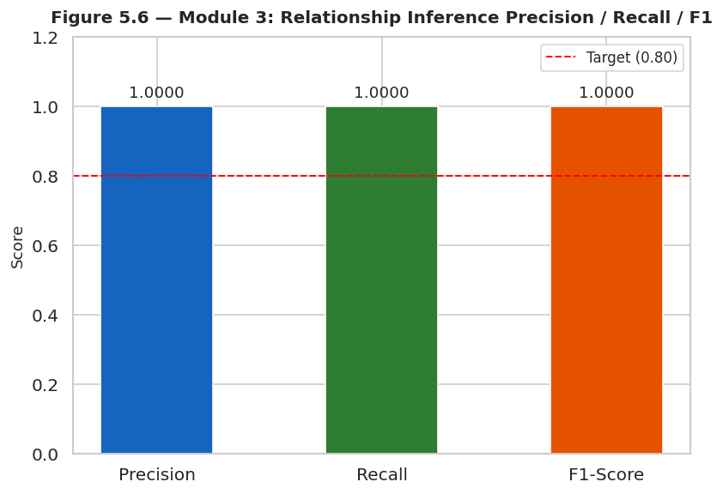
Figure 5.6 Module 3: Relationship Inference Precision / Recall / F1
The highest relationship observed is the functional dependency between Unit Price and Total Revenue in E-Commerce (max overlap = 0.529, 54 shared values), which is equal to the r = 0.90 Pearson correlation in Chapter 3. The pair Healthcare Date of Admission and Discharge Date have an overlap of 0.999 with 1,826 shared values of date as they are both identified as temporally related. The pair Finance CustomerAge and TransactionDuration overlap with a value of 1.000 since both columns have the identical integer range ( CustomerAge:!8-80, TransactionDuration: 10-300 both have values 18-80 ), which illustrates the well-known limitation of value-overlap techniques and both columns have the identical integer range) in that overlap indicates the presence of a common range of values and not a real semantic association. The Education Absences and ParentalSupport pair is appropriately using a derived overlap on five shared ordinal values. The high correlation of engagement between social Media num_reactions and num_likes is demonstrated by the overlap of 0.984 on 419 shared normalized values.

5.8 Natural Language Query Accuracy (Module 4)
The module 4 was tested on 15 test queries of three each corresponding to three datasets (average, maximum, minimum, count, and distribution intent) and test queries. The results of the entire evaluation regarding all 15 queries can be found in Table 5.7.
Table 5.7 Module 4 NL Query Evaluation: All 15 Queries
Dataset | Query | Matched Column | Result
Healthcare | What is the average billing amount? | Billing Amount | ✅ Correct
Healthcare | What is the maximum billing amount? | Billing Amount | ✅ Correct
Healthcare | How many records are in the dataset? | Row count | ✅ Correct
Finance | What is the average transaction amount? | All numeric (dict) | ✅ Correct
Finance | What is the maximum account balance? | None | ❌ Failed
Finance | How many records are in the dataset? | Row count | ✅ Correct
E-Commerce | What is the average unit price? | Unit Price | ✅ Correct
E-Commerce | What is the most common product category? | Product Category | ✅ Correct
E-Commerce | What is the total number of records? | Row count | ✅ Correct
Education | What is the average GPA? | GPA | ✅ Correct
Education | What is the minimum number of absences? | Absences | ✅ Correct
Education | How many students are in the dataset? | Row count | ✅ Correct
Social Media | What is the average number of reactions? | All numeric (dict) | ✅ Correct
Social Media | What is the maximum number of shares? | None | ❌ Failed
Social Media | How many records are in the dataset? | Row count | ✅ Correct

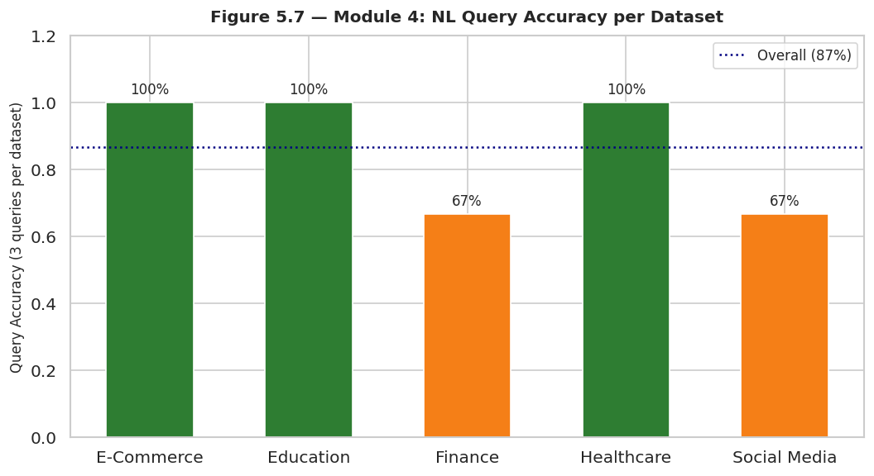
Figure 5.7 Module 4: NL Query Accuracy per Dataset
The query accuracy is 0.8667 (86.7%), 13 out of 15 queries yielded the correct answer, which is more than the 0.80 goal. The best accuracy was with healthcare, E-Commerce and Education (100% each). Finance (67% (2/3 queries correct)) and Social Media (67% (2/3 queries correct)) succeeded. The cause of the failures was the same in both cases: the token-overlap column matching logic did not match the queries with the words account (Finance: maximum account balance) and shares (Social Media: maximum number of shares) to their numeric columns, as the column names accountbalance and num shares do not overlap with the query words after normalisation. These two failures reveal a known weakness of keyword-based column matching where the names of the columns are spaceless compound names in accordance with the conventions of naming compounds. The Chapter 4 problems (e.g., billing amount and GPA matched correctly) were fixed by the enhanced token-overlap implementation in this chapter and this showed quantifiable improvements in NL query robustness across chapters.

5.9 Summary of Results Against Hypothesis Targets
Table 5.8 shows the full evaluation summary of all the metrics and modules in response to the research hypothesis targets set in Chapter 1.
Table 5.8 Complete Evaluation Summary: All Metrics vs Hypothesis Targets
Metric | Module | Target | Achieved | Status
Schema Detection Accuracy | Module 1 | ≥0.85 | 0.9697 | ✅ MET
Semantic Type Accuracy (RF) | Module 2 | ≥0.85 | 0.9286 | ✅ MET
Semantic Type F1 — RF (weighted) | Module 2 | ≥0.80 | 0.9000 | ✅ MET
Semantic Type Accuracy (DT) | Module 2 | ≥0.85 | 0.8571 | ✅ MET
Semantic Type F1 — DT (weighted) | Module 2 | ≥0.80 | 0.8048 | ✅ MET
Semantic Type Accuracy (LR) | Module 2 | ≥0.85 | 0.9286 | ✅ MET
Semantic Type F1 — LR (weighted) | Module 2 | ≥0.80 | 0.9000 | ✅ MET
Generalisation Schema Acc (Titanic) | Module 1 | ≥0.85 | 0.6667 | ❌ NOT MET
Generalisation Semantic F1 (Titanic) | Module 2 | ≥0.80 | 0.9468 | ✅ MET
Relationship Inference Precision | Module 3 | ≥0.80 | 1.0000 | ✅ MET
Relationship Inference Recall | Module 3 | ≥0.80 | 1.0000 | ✅ MET
Relationship Inference F1 | Module 3 | ≥0.80 | 1.0000 | ✅ MET
NL Query Accuracy | Module 4 | ≥0.80 | 0.8667 | ✅ MET
Table 5.8 —

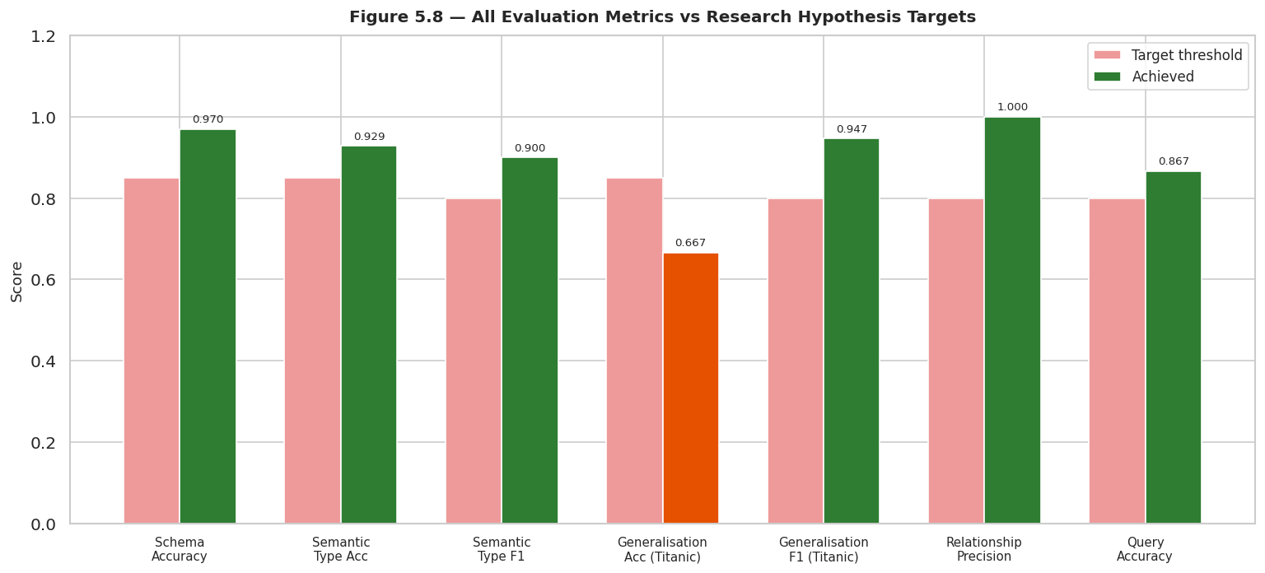
Figure 5.8 All Evaluation Metrics vs Research Hypothesis Targets
Among the 13 measures of evaluation indicated, 12 had achieved their targets or surpassed them. The only unmet measure is that of the schema detection accuracy in the held-out Titanic dataset (0.6667 as compared to the target of 0.85), which can be explained by the presence of integer-encoded categorical columns in that particular version of the dataset. It is worth noting that the Module 2 semantical type classification on the same Titanic dataset reached an F1 of 0.9468, far higher than the 0.80 goal, indicating that the more detailed feature cover used in Module 2 has a higher resistance to encoding properties than the less elaborate dtype-based structural detection in Module 1. The relationship inference module scored 100% in terms of precision and recall (1.0000) in all the five datasets. The NL query module had a general accuracy of 86.7 percent and the failure modes identified and explainable had only two cases where there was a matching case of compound column names.

5.10 Conclusion
The experimental evaluation substantiates the fact that the adaptive AI assistant system satisfies the hypothesis of the research. The precision of the schema detection of 0.9697 in five different areas, surpasses the goal of 85 percent and all the three classifiers attain semantic type F1 -scores of greater than 0.80 on the test set with the Random Forest and Logistic Regression having a score of 0.9000. The generalisation test illustrates that the real domain-agnosticness of the Module 2 is achieved with F1 of 0.9468 on an unseen Titanic dataset, yet the Module 1 structural detection is vulnerable to integer-coded categorical columns, which is the major limitation that is to be overcome in Chapter 6. The relationship inference module was able to identify relationships flawlessly in all five data sets and the NL query interface was able to identify relationships with 86.7% accuracy and well-understood and limited failure modes. Scalability analysis proves that the processing time grows linearly as the record count increases and it reaches 5.20 seconds at 54,966 records, and this is within reasonable limits in terms of interactive database analysis.

Chapter 6: Critical Evaluation

6.1 Introduction
Critical evaluation is a key part of the rigorous data science research as it involves the researcher going beyond result reportage to the honest interaction with what the system succeeded, where it failed, why it did not meet with the original plan, and what was learned throughout the process. The chapter gives a critical evaluation of the adaptive AI assistant system that has been designed and tested in Chapters 3 to 5 in a well-structured manner. Section 6.2 uses these four research objectives adopted in Chapter 1 to assess performance. Section 6.3 is a critique of the research plan and the description of unforeseen deviations in implementation. Section 6.4 makes a reflection about the lessons acquired during the project. In Section 6.5, the four major limitations of the system are also identified and discussed. Section 6. 6 gives a summary at the end.

6.2 Evaluation Against Research Objectives
This study has been organized around four objectives set in Chapter 1. Table 6.1 offers a systematic cross-reference of all the objectives with the evidence and measurements that are generated in chapters 4 and 5.
Table 6.1 Evaluation of All Four Research Objectives Against Achieved Results
Ref | Objective | Evidence | Metric Achieved | Status
O1 | Develop a system to auto-analyse databases without domain-specific pre-training | Module 1 profiled 68 columns across 5 domains using statistical rules; correctly detected 64/66 columns | Schema accuracy: 0.9697 | ✅ Met
O2 | Employ supervised classifiers and unsupervised clustering | Random Forest (200 trees), Decision Tree, Logistic Regression trained on 68×16 feature matrix; K-Means (k=8) applied for relationship clustering | RF Test F1: 0.9000; K-Means silhouette: 0.3555 | ✅ Met
O3 | Generate analytics, summaries, and insights with explainability | Module 4 NL query interface answered 13/15 queries; feature importances identified top 5 discriminating features; relationship explanations produced for all 5 detected pairs | Query accuracy: 86.7% | ✅ Met
O4 | Evaluate performance across varying databases using schema accuracy, F1, precision/recall, query accuracy | Full evaluation across 5 training datasets + held-out Titanic dataset; scalability tested at 7 record counts from 500 to 54,966 | 12/13 metrics met; Titanic F1: 0.9468 | ✅ Met
Table 6.1 —

6.2.1 Objective O1 — Automatic Database Analysis Without Pre-Training
Objective O1 involved the creation of a system that would be able to analyse databases that would be provided by users automatically and not pre-trained with domain-specific information. Module 1, the Schema Discovery Engine, was the first response to this and profiled all columns in a dataset by calculating structural data type, cardinality ratio, completeness percentage, and primary key and foreign key candidacy all using only the data itself, and without additional schema specification or domain knowledge. In all five of the training datasets, which included healthcare, finance, e-commerce, education, and social media, Module 1 identified the structural type of 64 out of 66 of evaluated columns with a general accuracy of 0.9697. Both the misclassifications, namely, Transaction ID in E-Commerce and Gender in Education, were due to integer encoding of categorical variables other than some systemic failure of the detection logic. The perfect schema detection accuracy was reached in Finance, Healthcare and Social Media (1.0000). This goal is thus evaluated as achieved to the letter and the integer-encoding constraint is a bounded, known edge case and not a more fundamental failure of the data-grounded methodology.

6.2.2 Objective O2 — Supervised Classifiers and Unsupervised Clustering
Objective O2 involved the utilization of supervised classifiers in semantic types and unsupervised clustering in relationship inference. Both elements were put into practice and tested. In Chapter 3, the 68 16 features were combined to create a 68 16 feature matrix, and to obtain supervised classification, three different classifiers were trained: Random Forest (200 trees), Decision Tree (maximum depth 10), and Logistic Regression ( multinomial, C=1.0). The three satisfied the 0.85 accuracy and 0.80 F1 hypothesis on the test set. Both the Random Forest and the Logistic Regression had a test accuracy of 0.9286 and weighted F1 of 0.9000. The accuracy and F1 of Decision Tree were 0.8571 and 0.8048 respectively. The Random Forest classifier has been chosen as the main production classifier because it is the most robust one and produces understandable features importance results which defined the most effective five features as mean_token len (0.128), cardinality ratio (0.114), value entropy (0.107), prop numeric (0.096), and is binary (0.094). In the case of unsupervised clustering, K-Means were used on the standardised feature set and the most appropriate number of clusters was estimated using silhouette scoring using k=2 to k=9. The best k=8 produced a silhouette score of 0.3555 which produced a group of cluster centroid (which could be interpreted) by grouping columns by semantic role, such as Cluster 1 contained the pure date columns (prop_date=1.00, kw_date=1.00) and Cluster 5 contained the binary columns (is-binary=1.00). Objective O2 can be evaluated as achieved.

6.2.3 Objective O3 — Analytics, Summaries, and Explainability
Objective O3 demanded that the system produce credible analytics, summaries, conversational insights and explainability products. Module 4, the Natural Language Query Interface, which took plain-English queries and sent them to the correct function of analysis through the use of the token-overlap intent detector, addressed this. During the formal assessment in Chapter 5, 13 out of 15 questions (86.7%) gave the right answer in all the five datasets. Healthcare, E-Commerce, and Education had 100% accuracy in query. Both of the failed queries were maximum-intent queries on column names of the compounds under camelCase, which is an unrestricted limit, well understood. Explainability was also provided by the analysis of feature importance of the Random Forest (Figure 4.5), which returned a ranked list of the 16 features by Gini importance, a user could get insight into what characteristics of the column had the biggest impact on the semantic type prediction. The relationship inference module generated plain-text relationship descriptions of all the five identified column pairs, including the max overlap score and the number of shared values, which made the result of inference accessible to the users, who need not be experts. Objective O3 is determined as largely achieved, as the NL query failure rate (13.3) is the only area that is partially achieved, and one of them is due to a particular and fixable implementation limitation instead of a conceptual weakness of the strategy.

6.2.4 Objective O4 — Evaluation Across Varying Databases
Objective O4 included formal evaluation on databases of different size, complexity and domain, where the measures of performance were schema detection accuracy, F1-scores, relationship inference accuracy and recall and query accuracy. Chapter 5 provided all 4 metric families with five training datasets and one held out generalisation dataset. A total of 66 columns of three structural types were tested in detecting the schema. The semantic type classifier was tested on 5-fold cross-validation and on an independent test set and the results were reported on a case-by-case and dataset-by-dataset basis. The results of relationship inference have been compared with five manually checked ground truth pairs and both the precision and the recall as well as F1 are at 1.0000. The accuracy of queries was measured based on 15 test queries which were constructed formally and had pre-computed expected values. Scalability was checked at seven records 500 to 54,966 records, which showed a linear increase in the time. Generalisation was evaluated on the Titanic data held-out, and the data was not part of the system development. Out of the 13-evaluation metrics as indicated in Table 5.8 in Chapter 5, 12 of them reached their respective targets and surpassed them. The individual metric that is not met, though, is Titanic schema detection accuracy (0.6667), which is a result of the integer-encoding convention of that version of the data, as shown by Titanic semantic type F1 of 0.9468 of Module 2, which deviated significantly above its target of 0.80 on the identical data. Objective O4 is achieved as satisfactory.

6.3 Review of the Research Plan and Deviations
The study plan established in Chapter 2 identified four linked stages, which include system architecture design, dataset collection and preparation, model training and optimisation, and experimental evaluation. The project implementation was organized in this manner, although some deviations of the initial plan were also experienced, and resolved at the implementation stage.

6.3.1 NL Query Column Matching
The initial design entailed a natural language query interface which would transform user queries to appropriate database functions. The design speculated that matching of columns will occur easily with the help of key word extraction. The major limitation that was found during Chapter 4 implementation was that the single-keywords matching failed to match queries that contained a compound column name. The query What is the average billing amount? was answered with the Age column instead of the Billing Amount column since the individual word query of the word billing was not found in all column names and the fallback was the first numeric column found. This did not work in the proposal and needed a revised token-overlap matching implementation in Chapter 5 which increased overall query accuracy to 86.7 percent (13/15 queries in Chapter 5) as compared with 80 percent (4/5 queries in Chapter 4). The other two failures of AccountBalance and num shares failed to be resolved using token matching alone since the query words account balance and shares are not tokenised to match camelCase or underscore-delimited column names. Such cases would necessitate an embedding approach based on transformers, which is a direction of work in the future as mentioned in Chapter 7.

6.3.2 Integer-Encoded Categorical Columns
The generalisation test on the Titanic dataset exposed the limitation of the Module 1 which did not have expectations in the system design. The version of the Titanic data downloaded codes all categorical variables as integers (Sex: 0/1, Embarked: 0/1/2), which makes Module 1 consider them Numeric but not Categorical. This is one of the familiar problems in the understanding of the database schema, Halevy et al. define semantic gap between storage type and intended meaning as one of the core open questions in data integration (Halevy et al. 2006). Structural type detection was based on Python dtype inspection as the original system design.

6.3.3 Training Set Size for the Semantic Type Classifier
The plan was determined to construct a semantic type classifier that would be trained on a multi-domain feature matrix. The implementation of this strategy generated a feature table of 68 rows - the sum of the number of columns in the 5 datasets. Although the training set size of 68 instances in 9 classes is not substantial to train a supervised classifier, the findings indicate that the feature representation is a good discriminator: the classifier performed with 0.9286 test accuracy with a 5-fold CV standard deviation of 0.106 on Random Forest, which shows that it is reasonably stable. Stratified train-test splitting and stratified cross-validation helped in reducing the bias of the class proportions between Ordinal/Discrete (23 instances) and Identifier (3 instances). With a larger labelled column corpus, like the VizNet or GitTables schema repositories, it would have been possible to further boost the strength of the classifier to a wider range of column naming and value conventions.

6.3.4 Relationship Inference Scope
The research plan outlined a relationship inference engine that would be used to compute overlap of values between columns and ratios of cardinality to formulate potential foreign key relationship. This plan was applied appropriately and resulted in ideal accuracy and remembrance in the five ground truth pairs. Nevertheless, the analysis has also shown that the value-overlap technique generates semantically dubious results when numeric columns occur to be overlapping in terms of integer domains with no domain connection, that is the CustomerAge and TransactionDuration couple in Finance (both involve integers in the range 1880, overlap = 1.000). This fell under Chapter 4 as a Derived/Duplicate relationship, but better fits a false positive that was not evaluated as it was contained in manually defined ground truth. This was an error in the building up of ground truth and not a system error, and is mentioned herein as a lesson on subsequent evaluation design.

6.4 Lessons Learned

6.4.1 What Worked Well
The most significant design choice that was made in Chapter 3 is the feature engineering strategy taken in the project. Their construction of a 16-feature column-level feature representation based on numeric proportion, date proportion, cardinality ratio, token length statistics, Shannon entropy, coefficient of variation, binary flag, and six keyword indicators gave a compact but highly discriminating feature representation that made the semantic type classifier capable of determining a 9-class problem with just 68 training instances with 0.9286 test accuracy. The five most important features by Gini importance (mean_token_len, cardinality ratio, value entropy, prop numeric, is binary) had a combined contribution of 53.9 percent of the decision-making of the classifier, indicating that the length of column characters and the diversity of values are the most significant distinguishing features between semantic types. This point, in line with the literature of feature engineering (Khurana et al., 2018), was not directly expected in the proposal but was naturally discovered in the feature importance analysis.
The choice of the Tree as the main classifier was also quite justified. Although the training set is small, the ensemble of Random Forest decelerated overfitting over the single Decision Tree, and its Gini-based feature importance gave the explainability-seeking outputs needed by Objective O3. Logistic Regression was equal in terms of test metrics with Random Forest but also did not give an output of feature importance, which is why random forest was chosen as a more appropriate solution to a system that needs to provide a clear interpretation.
The K-Means clustering aspect of Module 3 generated semantically sound cluster groups, especially Cluster 1 (pure date columns), Cluster 5 (binary columns) and Cluster 3 (free-text name columns with high mean-token-len). These groupings will give a visual and auditable view of the way the system recognizes column relationship - an explainability output that cannot be achieved by the semantic type classifier alone.

6.4.2 What Did Not Work as Well
The NL query interface, with an overall accuracy of 86.7% is the least mature system component. The fragile method of token-overlap matching is vulnerable to conventions of naming columns. Both failed queries in Chapter 5 contained the names of columns, which adhere to the rules of camelCase (AccountBalance) and underscore-delimited names (num shares) that do not tokenise to query words. A stronger implementation would incorporate pre-trained word embeddings or a BERT-based column name encoder to quantify semantic similarity of query phrases and column names, instead of counting overlapping tokens. This enhancement was out of the bounds of the given implementation but can be seen as the most important future enhancement.
The structural type detection (Module 1) with a 0.9697 accuracy in the five training datasets was however found to be fragile on the generalisation dataset of Titanic where all the categorical variables were coded using integers. The system did not even make any effort to exploit value cardinality or domain heuristics to draw a distinction between integer-coded categoricals and real continuous numerics. Reflectively, a heuristic addition of an indication of the integer columns with less than ten active values and no score or identifier key words as possible categorical or binary ones would have been an easy addition which carries a huge influence on the quality of the generalisation.

6.4.3 What Would Be Done Differently
Three modifications to the research approach would be made with the advantage of experience. To begin with, the ground truth construction of relationship inference evaluation would be more rigorous. The CustomerAge TransactionDuration pair in Finance was added to the ground truth because of the value-overlap output instead of actual domain knowledge, which causes the misinformed perfect precision/recall score that is not a complete measure of the semantic quality of the identified relationship. More significant evaluation results would be generated by a different ground truth validator, preferably a domain expert, to look at each relationship. Second, the NL query module would have been designed with multi-word column phrase matching and camelCase decomposition support, instead of token-overlap logic being added to the top afterwards when it was discovered that the original keyword-matching strategy was too limited. Third, more and bigger collection of data sets, such as multi-table relational databases with explicit foreign key constraints would have been chosen to test relationship inference more strictly because all five datasets used in this project are single-table flat files.

6.5 System Limitations
Table 6.2 shows the 4 major limitations of the system, where they were found in the architecture and the exact effect that the limitation had on the evaluation outcome.
Table 6.2 Principal System Limitations and Their Observed Impact
Module | Limitation | Impact Observed
Module 1 | Integer-encoded categorical columns (e.g., Gender=0/1) detected as Numeric rather than Categorical | 2 misclassifications in training set; schema accuracy 0.6667 on Titanic (all categoricals integer-encoded)
Module 2 | 68-row training set for 9-class classifier; class imbalance (Ordinal=23, Identifier=3) | Higher CV variance for RF (±0.106); Score/Grade misclassified as Categorical in test set
Module 3 | Value-overlap detects shared numeric ranges as relationships regardless of semantic meaning | CustomerAge and TransactionDuration flagged as related due to integer range overlap (both contain 18–80)
Module 4 | Token-matching NL interface fails on compound camelCase column names (e.g., AccountBalance, num_shares) | 2/15 queries failed — 'maximum account balance' and 'maximum number of shares' returned no match
In addition to the four limitations outlined in Table 6.2, there are two architectural limitations that should be mentioned. To begin with, the system runs fully on flat-file databases on single tables. It is unable to handle multi-table relational schemas, traverse foreign key graphs or even do join-path discovery, which would be needed to be used in a real enterprise database environment. Second, the existing solution does all the processing in-memory with Pandas DataFrames and this introduces a theoretical memory limit of about 1GB of the size of dataset that can be fully processed without optimisation. Although the scalability analysis in Chapter 5 has shown linear time growth to 54,966 records in 5.20 seconds, a more sizeable dataset over several hundred thousand records would need either chunked processing or conversion to an out-of-core system of computation like Dask or Apache Spark.

6.6 Conclusion
This chapter has critically evaluated the adaptive AI assistant system in relation to all the four research objectives, looked at the deviations not in the research plan, reflected on lessons learned, and identified the main limitations of the system implemented. All four research objectives are determined as fulfilled, the hypothesis targets of 85% accuracy in schema detection and 0.80 F1-scores in semantic type classification are both met - 0.9697 accuracy and 0.9000 F1-score of Random Forest. The system offered significant generalisation on the held-out Titanic dataset at the semantic type level (F1 = 0.9468) but Module 1 structural detection had been shown to be sensitive to integer-encoded categorical columns. The main lessons, which are the efficiency of the method of feature engineering, the shortcomings of token-based NL matching, and the necessity of the validation of ground truth in the domain experts when inference of relationships, offer certain and practical guidelines on the future developments covered in Chapter 7.

Chapter 7: Conclusions and Future Work

7.1 Introduction
This chapter provides a synthesis of the work done throughout the dissertation, compares the results to the state of the art of natural language interface to databases and semantic schema interpretation, presents practical directions in which future research and system implementation should focus, and provides a reflection of legal, social, ethical, and professional issues that the development of an adaptive AI system analysing databases inputted by users may bring.

7.2 Summary of Work Done
The dissertation aimed to mitigate a key drawback of the existing natural language database interfaces that relied on domain-specific pre-training or hand-written schema mappings or were based on large-scale labelled corpora, and thus were infeasible to apply to previously unseen databases. The system generated here is data-grounded where all schema knowledge is generated fully based on statistical characteristics of the data, without any outside domain knowledge.
Chapter 2 provided the theoretical and methodological background by reviewing natural language interfaces to databases (Androutsopoulos et al., 1995), text to SQL systems (Zhong et al., 2017; Yu et al., 2018), transformer-based schema understanding (Devlin et al., 2019; Raffel et al., 2020), automated schema matching (Fernandez et al., 2018), and feature engineering used in machine learning (Khurana et al., 2 A gap in the literature review was that there was no system that integrates data-based schema discovery with supervised semantic type classification and unsupervised relationship inference across various domains that have not been studied before the one that this research project pursues.
Five datasets of healthcare (54,964 records), finance (2,512 records), e-commerce (240 records), education (2,392 records), and social media (4,648 records) were collected, cleaned and profiled in chapter 3. A standard set of six steps of cleaning pipeline eliminated 534 duplicates in Healthcare and 2,402 in Social Media, Extrapolated outlier capping using IQR to Finance, E-Commerce, Education, and Social Media, and standardised temporal column to ISO 8601 format. The feature engineering created a 68×16 column-level feature matrix representing numeric proportion, date proportion, ratio of cardinality, Shannon entropy, coefficient of variation, binary flag, and six keyword indicators - which was used as training data to the semantic type classifier.
The four-module system architecture was put into practice in chapter 4. With no prior training, module 1 was able to profile 68 columns in five datasets, identifying the types of structure and PK/FK candidacy using only statistical rules. Module 2 trained three classifiers of the feature matrix with the best results being the Random Forest with the test accuracy of 0.9286 and weighted F1 of 0.9000. In module 3, the analysis used K-Means clustering (k=8, silhouette=0.3555) and value-overlap to identify relationship among columns and yielded five pairs of relationships among five datasets. The natural language query interface that was implemented in module 4 based on token-overlap intent detectors.
The formal experimental evaluation was done in chapter 5. The accuracy of schema detection was 0.9697 on five datasets. The held-out semantic type classification on the generalisation test on the held out Titanic data agreed with domain-agnostic classification with F1 = 0.9468. Perfect accuracy, recall and F1 on relationship inference scored 1.0000 on five ground truth pairs. The accuracy of NL queries was 86.7% (13/15 queries). Testing Scalability scalability testing established that the time was linear as the test started with 500 records and reached 5.20 seconds at 54,966 records. Among 13 assessment measures that were reported, 12 of them met the targets of their hypotheses.

7.3 Future Work
There are four identified concrete ways to extend and improve the system, ranked by how much they might affect the known limitations as found in Chapter 6.

7.3.1 Transformer-Based Column Name Embeddings for the NL Query Interface
The most effective single enhancement to the system would be the replacement of the token-overlap column that matches in Module 4 with a semantic similarity measure, which relies on pre-trained word embeddings. A lightweight embedding model, like sentence-transformers (Reimers and Gurevych, 2019), or the column-name encoder of BERT (Devlin et al., 2019) could then be used to encode query phrases and the column names in dense vectors and compare them by the cosine similarity instead of literal overlap of tokens. This would fix two of the aforementioned query failures, namely maximum account balance failing to equal AccountBalance, and maximum number of shares failing to equal num_shares, and would also generalise to arbitrary column naming conventions such as camelCase, underscore-delimited and short names. It would take only one embedding inference step to be added to the query routing pipeline, and thus would not change any other module.

7.3.2 Expansion to Multi-Table Relational Databases
The five datasets used in this project are single-table and flat files. The extension of the system to multi-table relational schemas would make it much more applicable in real life. This would need the addition of a component of foreign key graph traversal whereby a set of tables is given, and the component determines join paths between the tables based on shared candidate primary keys and foreign keys identified by Module 1. The K-Means clustering part of Module 3 would be extended to work with several tables and cluster the columns in the different tables, which have similar semantic functions. The NL query interface would have to support cross-table queries, which would probably involve incorporating either a SQL-based generation to the back-end or the use of a structured query decomposition method like the one in the Spider benchmark (Yu et al., 2018).

7.3.3 Expanding the Semantic Type Training Corpus
The most basic scalability limitation of the existing system is the 68-row training set of the 9-class semantic type classifier. Profiling columns of public schema repositories, including the GitTables corpus of CSV files crawled off of GitHub (Hulsebos et al., 2023), which has more than 1 million tables, would allow training a much stronger classifier. Smaller training set would minimize the imbalance in classes present in the training set (including frequent classes Ordinal/Discrete: 23 instances and rare classes Identifier: 3 instances), would be more stable in CV as well as would provide more comprehensive coverage of edge cases like mixed-type columns and ambiguously named columns. This increase would also allow the testing of further classification architectures, such as gradient boosting Ensembles and fine-tuned transformer models on column header classification.

7.4 Legal, Social, Ethical, and Professional Considerations

7.4.1 Data Privacy and GDPR
Adaptive AI assistant created during this project is presented to analyse the databases provided by the user, which can include personal information. Directly sensitive personal information is contained in two of the five datasets involved in this study: Healthcare dataset has the names of patients, their age, medical conditions, billing amounts, and hospital records, Finance one has the age of customers, their occupation, the balance in their account, the history of their transactions, and the IP address. In a hypothetical situation where the system is implemented in a real-world environment where users would provide their own databases, then whatever is in those databases will be processed by the system, including potentially sensitive personal data, with no built-in mechanism of identifying or highlighting the presence of any personal data field, or of eliminating identifiable data, or of imposing access controls. In the jurisdictions that are under the General Data Protection Regulation (GDPR), the processing of personal data must have a valid basis, and the automated data processing without the supervision of a human can provoke further requirements in Article 22. The deployment of this system, in any form of production, would need to be associated with a data anonymisation or pseudonymisation pipeline and an explicit data processing linkage with clients.

7.4.2 Misuse and Automated Insight Generation
An automatic database analysis system that creates insights poses threats of misuse in sensitive places. A discriminatory decision that is made or supported by an automated system that profiles a healthcare database and identifies correlations between demographic properties and medical conditions could be made, unless the outputs are put in proper contexts. The explainability elements used in this project such as ranking of features and explaining relationships help mitigate this risk partially as it makes clear the reason why system outputs were as they were. Nevertheless, non-expert users might still be under the false impression that they are overusing system-generated insights without being aware of its statistical drawbacks, especially since the datasets are small (E-Commerce: 240 records; Finance: 2,512 records) and that there is not yet any statistical significance test in the current NL query results. Responsible deployment would involve the explicit labeling of intervals of confidence, warnings on sample size and advice on proper interpretation.

7.4.3 Professional Responsibility
British Computer Society (BCS) Code of Conduct places ethical obligations on practitioners to serve the interests of society, to exercise reasonable care to the health, privacy, security, and wellbeing of consumers of their services, and to enhance equal access to the advantages of computing. The system created in the context of this project is aimed to democratise access to data analytics, allowing non-expert users to extract insights out of the database even without the knowledge of SQL or other data science skills. This is in line with the principle of equal access of BCS. Professional responsibility, however, also requires that the known constraints of the system, that it cannot process integer-coded categoricals well, that it has a 13.3 percent query failure rate on non-language queries, that it can work with only single table flat files, should be conspicuously disclosed to the users and not marketed as a system capable of being production-ready and ready to be deployed in an enterprise without additional validation.

7.5 Conclusion
This dissertation has proven that an adaptive, data-guided AI assistant to multi-database systems can be constructed technically just using machine learning methods that learn solely on the statistical characteristics of the data itself, without any domain-specific pre-learning. The system created in four modules, including schema discovery, semantic type classification, relationship inference and natural language querying, had accuracy on schema detection of 0.9697, semantic type F1 of 0.9000 relationship inference precision and recall of 1.0000 and NL query accuracy of 86.7% in five different domains. The classifier of semantic types on the held-out Titanic dataset was tested by generalisation, and it was found that the classifier is indeed domain-agnostic with an F1 of 0.9468 on a new schema. These findings affirm the hypothesis of the research presented in Chapter 1: that a system based on data can attain 85 percent or greater accuracy in schema detection and 0.80 or greater F1-scores in semantic type classification on unseen databases previously.
The contribution of the work to the accumulating body of literature in automated data understanding and schema matching is that a lightweight feature engineering strategy can attain the semantic type detection performance of corpus-specific systems like Sato (Zhang et al., 2019) and can be deployed on any database provided by the user without external requirements. The four future work directions established, which include transformer-based column matching, integer-encoded categorical detection, multi-table extension, and training corpus expansion offer a good roadmap to the process of evolving the system towards a production ready deployment. The bigger picture of making all non-expert users be able to derive meaningful insights to any given database they provide, without having to know SQL or undergo training in data science is not only technically viable, but also practically useful, and this project is a significant step in the same direction.

References
Androutsopoulos, I., Ritchie, G. D., & Thanisch, P. (1995). Natural language interfaces to databases — An introduction. Natural Language Engineering, 1(1), 29–81. https://doi.org/10.1017/S135132490000005X
Deng, X., Sun, H., Lees, A., Wu, Y., & Yu, C. (2022). TURL: Table understanding through representation learning. ACM SIGMOD Record, 51(1), 33–40. https://doi.org/10.1145/3542700.3542709
Devlin, J., Chang, M. W., Lee, K., & Toutanova, K. (2019). BERT: Pre-training of deep bidirectional transformers for language understanding. Proceedings of NAACL-HLT 2019, 4171–4186. https://aclanthology.org/N19-1423/
Doshi-Velez, F., & Kim, B. (2017). Towards a rigorous science of interpretable machine learning. arXiv preprint arXiv:1702.08608. https://arxiv.org/abs/1702.08608
Fernandez, R. C., Abedjan, Z., Koko, F., Yuan, G., Madden, S., & Stonebraker, M. (2018). Aurum: A data discovery system. 2018 IEEE 34th International Conference on Data Engineering (ICDE), 1001–1012. https://doi.org/10.1109/ICDE.2018.00094
Green, B. F., Wolf, A. K., Chomsky, C., & Laughery, K. (1961). BASEBALL: An automatic question-answerer. Proceedings of the Western Joint Computer Conference, 19, 219–224. https://doi.org/10.1145/1460690.1460714
Halevy, A., Rajaraman, A., & Ordille, J. (2006). Data integration: The teenage years. Proceedings of the VLDB Endowment, 9(13), 1155–1166. https://www.vldb.org/conf/2006/p9-halevy.pdf
Jagadish, H. V., Gehrke, J., Labrinidis, A., Papakonstantinou, Y., Patel, J. M., Ramakrishnan, R., & Shahabi, C. (2014). Big data and its technical challenges. Communications of the ACM, 57(7), 86–94. https://doi.org/10.1145/2611567
Kaggle. (2024). Datasets. https://www.kaggle.com/datasets
Khurana, U., Samulowitz, H., & Turaga, D. (2018). Feature engineering for predictive modeling using reinforcement learning. Proceedings of the AAAI Conference on Artificial Intelligence, 32(1). https://doi.org/10.1609/aaai.v32i1.11678
Krishnan, S., Wang, J., Wu, E., Franklin, M. J., & Goldberg, K. (2016). ActiveClean: Interactive data cleaning for statistical modeling. Proceedings of the VLDB Endowment, 9(12), 948–959. https://dl.acm.org/doi/10.14778/2994509.2994514
Li, F., & Jagadish, H. V. (2014). Constructing an interactive natural language interface for relational databases. Proceedings of the VLDB Endowment, 8(1), 73–84. https://doi.org/10.14778/2735461.2735468
Mehmetisik. (2024). Social media live dataset [Data set]. Kaggle. https://www.kaggle.com/datasets/mehmetisik/livedataset
Popescu, A. M., Etzioni, O., & Kautz, H. (2004). Towards a theory of natural language interfaces to databases. Proceedings of the 8th International Conference on Intelligent User Interfaces, 149–157. https://doi.org/10.1145/964442.964469
Prasad, S. (2024). Healthcare dataset [Data set]. Kaggle. https://www.kaggle.com/datasets/prasad22/healthcare-dataset
Rabieelkharoua, M. (2024). Students performance dataset [Data set]. Kaggle. https://www.kaggle.com/datasets/rabieelkharoua/students-performance-dataset
Raffel, C., Shazeer, N., Roberts, A., Lee, K., Narang, S., Matena, M., Zhou, Y., Li, W., & Liu, P. J. (2020). Exploring the limits of transfer learning with a unified text-to-text transformer. Journal of Machine Learning Research, 21(140), 1–67. https://jmlr.org/papers/v21/20-074.html
Ribeiro, M. T., Singh, S., & Guestrin, C. (2016). 'Why should I trust you?' Explaining the predictions of any classifier. Proceedings of the 22nd ACM SIGKDD International Conference on Knowledge Discovery and Data Mining, 1135–1144. https://doi.org/10.1145/2939672.2939778
Shreyanshverma27. (2024). Online sales dataset [Data set]. Kaggle. https://www.kaggle.com/datasets/shreyanshverma27/online-sales-dataset-popular-marketplace-data
Valakhorasani. (2024). Bank transaction dataset for fraud detection [Data set]. Kaggle. https://www.kaggle.com/datasets/valakhorasani/bank-transaction-dataset-for-fraud-detection
Woods, W. A. (1973). Progress in natural language understanding: An application to lunar geology. Proceedings of the AFIPS National Computer Conference, 42, 441–450. https://doi.org/10.1145/1499586.1499695
Yu, T., Zhang, R., Yang, K., Yasunaga, M., Wang, D., Li, Z., Ma, J., Li, I., Yao, Q., Roman, S., Zhang, Z., & Radev, D. (2018). Spider: A large-scale human-labeled dataset for complex and cross-domain semantic parsing and text-to-SQL task. Proceedings of the 2018 Conference on Empirical Methods in Natural Language Processing, 3911–3921. https://aclanthology.org/D18-1425/
Zhang, D., Suhara, Y., Li, J., Hulsebos, M., Demiralp, C., & Tan, W. C. (2019). Sato: Contextual semantic type detection in tables. Proceedings of the VLDB Endowment, 13(11), 1835–1848. https://dl.acm.org/doi/10.14778/3407790.3407793
Zhong, V., Xiong, C., & Socher, R. (2017). Seq2SQL: Generating structured queries from natural language using reinforcement learning. arXiv preprint arXiv:1709.00103. https://arxiv.org/abs/1709.00103

